# OpenNebula

## Introduction

I will be installing, setting up and configuring the Open Nebula cloud computing platform to host multiple virtual machines representing a virtual environment.

## Setup

For the setup of Open Nebula, I will create a file ‘opennebula.repo’ containing repository information, this allows access to the community edition. After this is done I will then install the EPEL (Extra packages for Enterprise Linux) release and Open Nebula and Open Nebula Sunstone packages.



Figure 1 - Creating repo file

Shown in Figure 1, I used gedit to create the opennebula.repo file within the etc/yum.repos.d directory

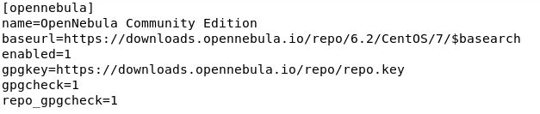

Figure 2 - Repo File Contents

Within opennebula.repo I included the text shown in Figure 2 as per the Open Nebula repository setup, (OpenNebula, n.d.)

## Activating Release

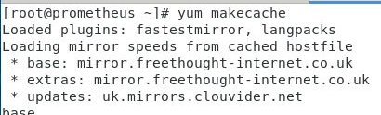

Figure 3 - Downloading Repository Data

Using the ‘yum makecache’ command, I re-downloaded all repository data, including the new Open Nebula repository.

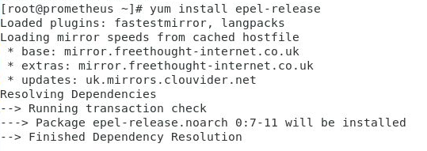

Figure 4 – Installing EPEL Repository

After downloading repository data, I then installed the EPEL release onto the system

## Installing Open Nebula Server

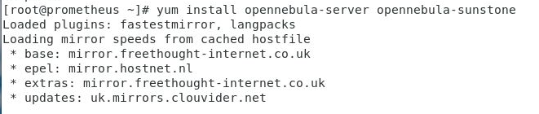

Figure 5 - Installing Open Nebula server & sunstone

Once the repository data and extra packages were downloaded I installed the Open Nebula server and its web interface sunstone

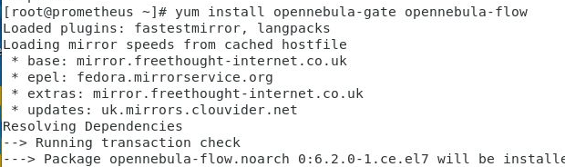

Figure 6 - Installing Packages

After installing the front end packages I then installed the back end components and packages for the virtualisation host.

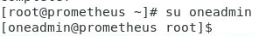

Figure 7 - Logon to Open Nebula (CLI)

Once the installation completed, I then logged in to the pre-configured oneadmin account



Figure 8 - Configuring oneadmin account password

Once logged in create a file in ~/root/.one/one_auth containing the username and password for the OpenNebula server.

Username: oneadmin

Password: localhost1

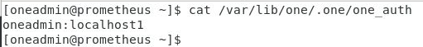

Figure 9 - Altered one_auth file

## Disabling FireEdge GUI



Figure 10 - Opening the sunstone-server.conf file

Next I opened the configuration file for the sunstone server to disable the firestone GUI. This is because I will be using the sunstone web interface to manage the cloud.

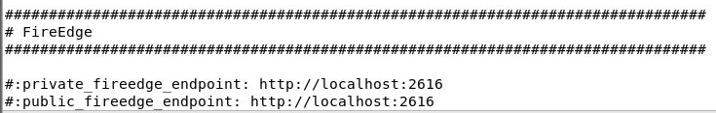

Figure 11 - Edited sunstone-server.conf file

I then commented out the last two lines of the file, these lines enable fire edge to run. By commenting them out I will be able to manage my cloud through the web interface.

## Starting the Server



Figure 12 - Starting Open Nebula & Sunstone

Once setup, I then started both the Open Nebula server and the Sunstone web interface.

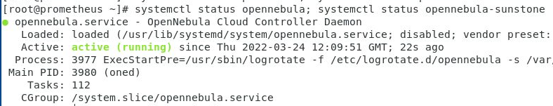

Figure 13 - Open Nebula Daemon Active

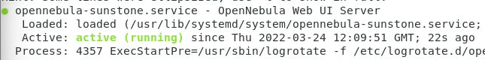

Figure 14 - Open Nebula Sunstone Web Interface Active

Then used the ’status’ command to verify the server and web interface were active on the system, Figures 13-14.

## Verifying Installation

Checking that commands are able to connect to the server daemon

### Linux CLI

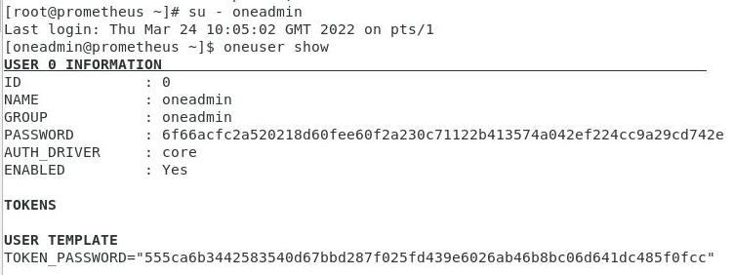

Figure 15 - Checking connection to Open Nebula Daemon

Figure 15 shows that commands connect to the Open Nebula daemon.

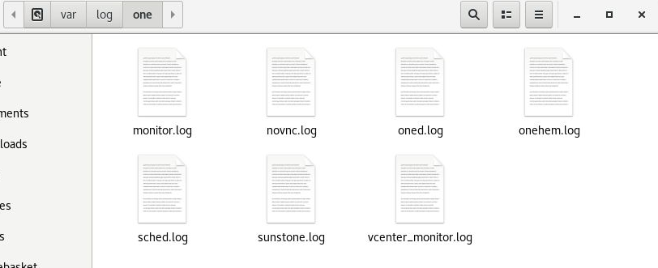

Figure 16 - var/log/one file structure

After setting up the server, files should be present in var/log/one specifically sched.log (schedule) and oned.log (core), Figure 16 shows these files are present.



Figure 17 - Error Checking using Grep

Using grep E will highlight the status code [E] in the log file showing any errors.



Figure 18 - Two database errors found

Two database errors were found, stating two tables are missing, local_db_versioni and db_versioning.

### Sunstone

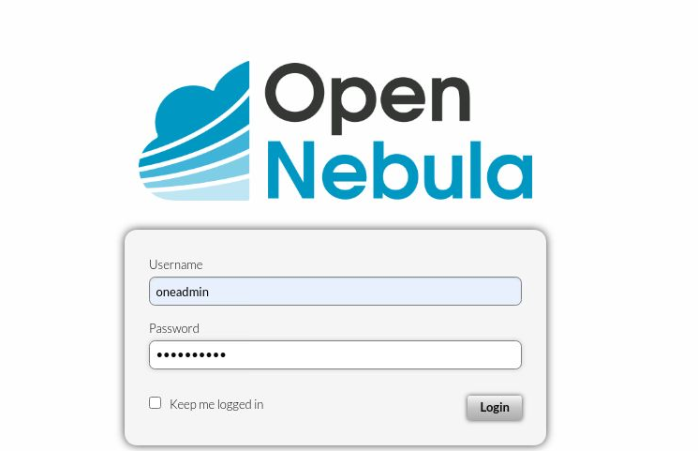

Figure 19 - Web Interface Login

The sunstone server is hosted on localhost:9696, using the username and password from the one_auth file, I logged into sunstone.

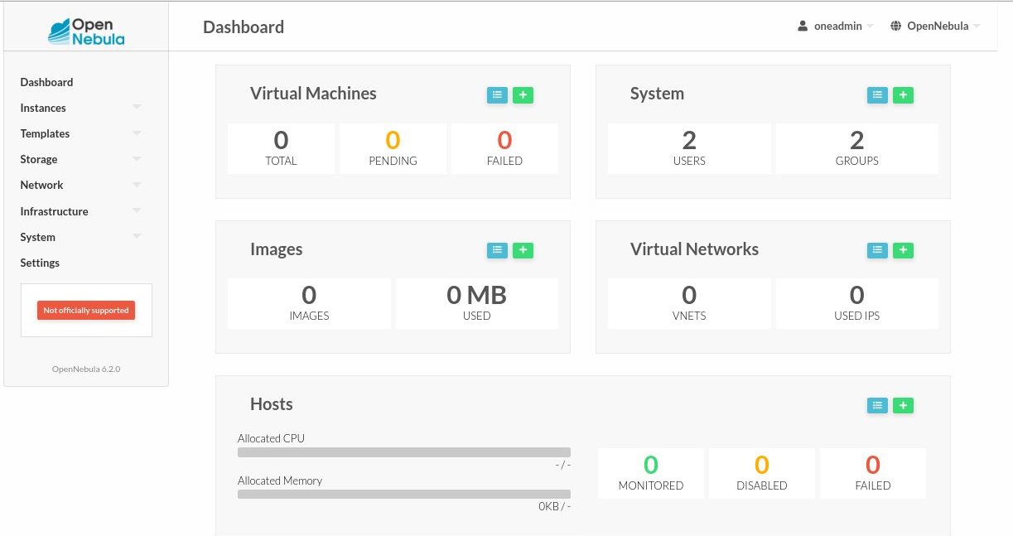

Figure 20 - Sunstone Dashboard

Once logged in the dashboard page is displayed, showing statistics of the server such as how many virtual networks, images, systems and virtual machines there are along with CPU and Memory usage.

## KVM Node Installation

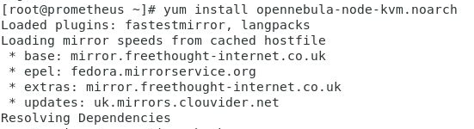

Figure 21 - Installing KVM Node

Installing KVM Node allows for linux to become a hypervisor. This means that I will be able to create virtual machines on open nebula, running them on the CentOS7 system.



Figure 22 - Restarting libvirt

After installing KVM Node, I restarted the libvirtd service, the daemon responsible for managing virtualisation.

## Passwordless Authentication



Figure 23 - Opening the ssh config file with vi

To configure passworldess authentication, I opened the ssh config file with vi.

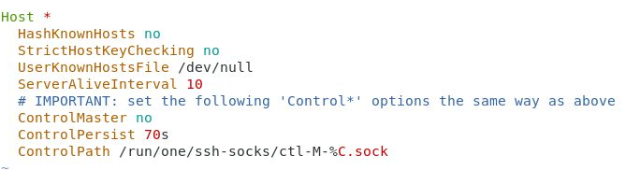

Figure 24 - Editing .ssh/config

Within the configuration file, I inserted “StrictHostKeyChecking” and set the value to no. This won’t check the key of the user that is trying to log into the server. Instead, when using SSH will look within the known user hosts file which I set to the /dev/null folder for validation of the user.



Figure 25 - Altering SSH Config File Permissions

I then set the configuration file permission to 600 meaning that it can only be read and written to by the owner.

### Testing Passwordless Authentication



Figure 26 - Testing Passwordless SSH

After the setup, I successfully used SSH to localhost without entering a password as expected.

## OpenNebula-SunStone Dashboard

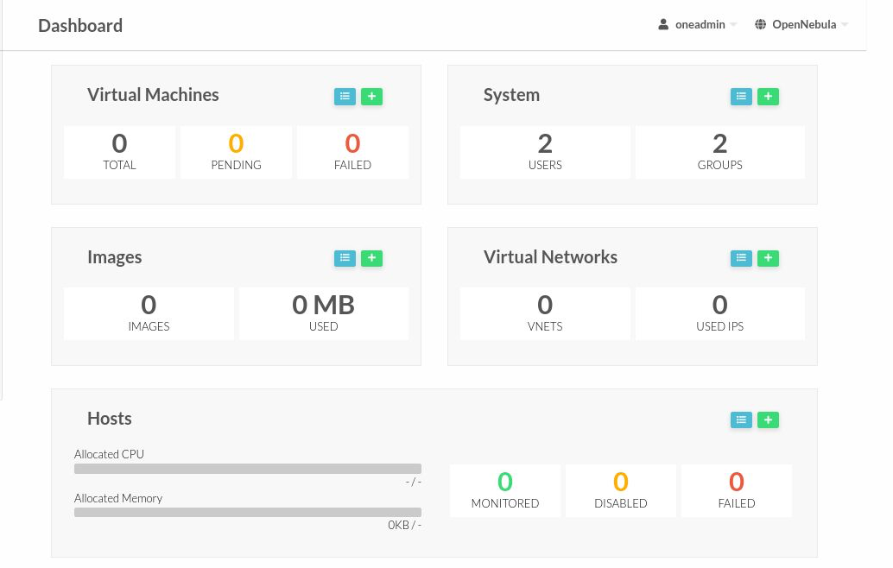

Figure 27 - Sunstone Dashboard

## OpenNebula Folder Structure

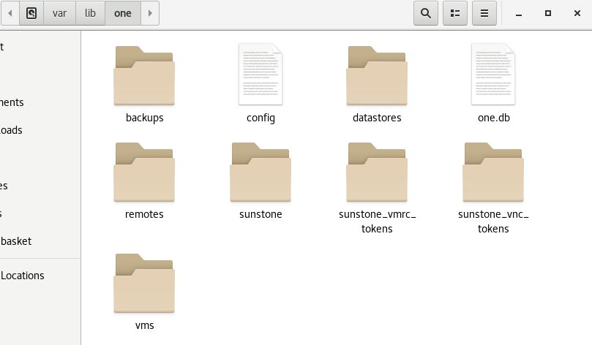

Figure 28 - File structure after full installation

# Sunstone

Within this section I will be carrying out the network configuration of the server, creating a bridged interface which Open Nebula will use. Once this is created I will then move over to Sunstone and configure the first virtual machine and the components required to set it up.

## Network Configuration

Explain that I will be configuring multiple files blah blah. Files that currently exist I will be creating copies and storing them in the root folder incase the configuration is wrong.

For the network configuration, I will be creating one new file ifcfg-br0 and copying the original ifcfg-ens33 to the home folder as I will also be editing this file.



Figure 29 - Backing up orignal ens33 file

Copy ifcfg-ens33 file to root directory. This is so I have a backup of the file.

To copy the ifcfg-ens33 file, I used the cp command and directed it to my root directory. This is done so I have a backup of the original file.

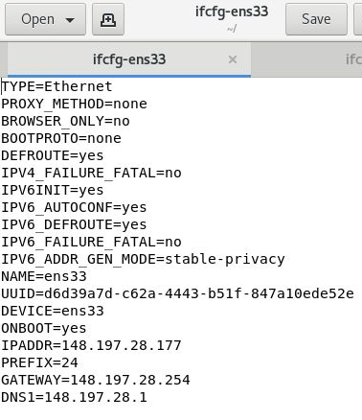

Figure 30 - Original ens33 file

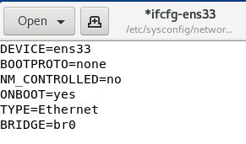

Figure 31 - Altered ens33 file

After backing up, I modified the configuration file, removing unnecessary statements. This file is now used to bridge the main network ‘ens33’ to the new ‘br0’ network.

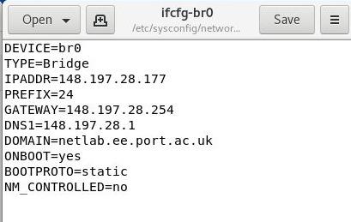

Figure 32 - Configuring bridged network

I then created the bridged configuration file using the IP address from Prometheus (148.197.28.177) as the bridged IP.



Figure 33 - Restarting Network Service

Once the configuration files were created, I then restarted the network service which will refresh the network adapters on the system.

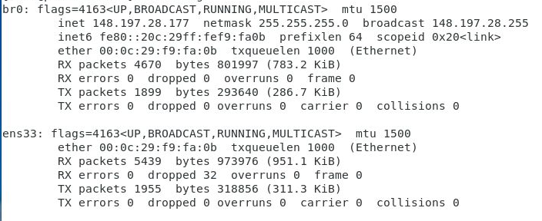

Figure 34 - New Bridged Adapter

After restarting the network service, ens33 no longer has an IP address and instead the IP address 148.197.28.177 is allocated to br0.

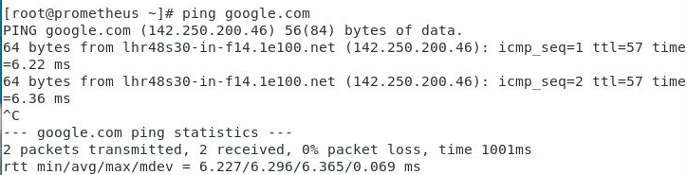

Figure 35 - Testing Internet Connection

With the change in network configuration, using ping I am still able to connect to connect outside of the network.

## Adding a host

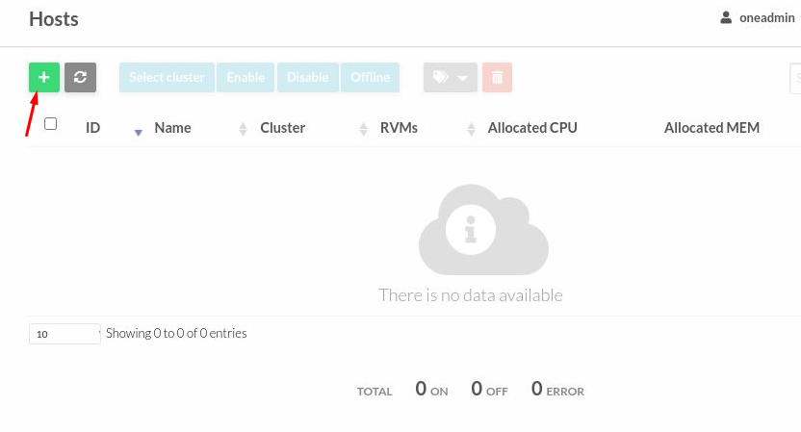

Figure 36 - Creating First Host

To create the first host, I selected the plus sign within Hosts on the Sunstone web interface which took me to the host creation menu

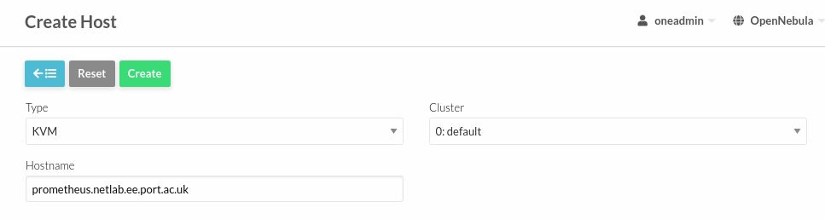

Figure 37 - Host Creation

I set the type of host to KVM (Kernal-based Virtual Machine) and set the hostname to the name to the machine name and the network address.

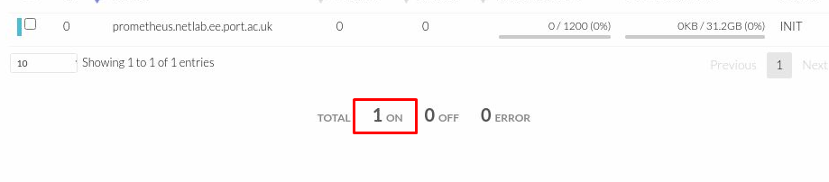

Figure 38 - Prometheus Host

After selecting create, the Prometheus host shows on as expected.

## Adding a datastore

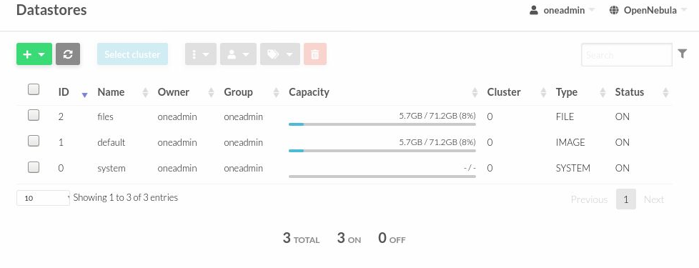

Figure 39 – Datastores

Within datastores, pre-configured stores can be found, files, default, and system. I did not alter these as they were setup as I wanted them.

## Adding Networks

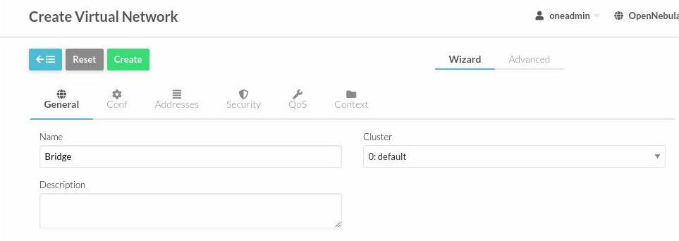

Figure 40 - Network Creation (General)

Within the general tab of the network creation, I set the name of the virtual network as Bridge, leaving the description and cluster as standard.

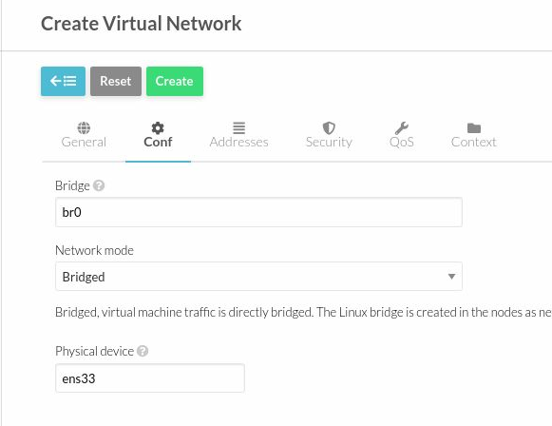

Figure 41 - Network Creation (Conf)

Moving into the conf menu, I entered br0 for the Bridge and ens33 for the physical device then selected Bridged network mode. This tells sunstone that the bridge is the br0 interface and is bridged using the ens33.

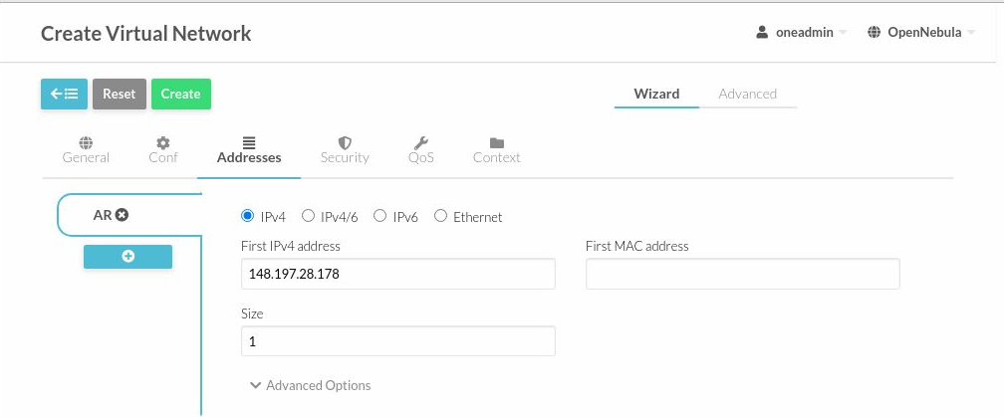

Figure 42 - Network Creation (Addresses)

Within the addresses tab, I configured the IPv4 address to be the Prometheus IP+1 and allocated it the size 1, i.e., the amount of virtual machines which can use this network.

## Adding Images

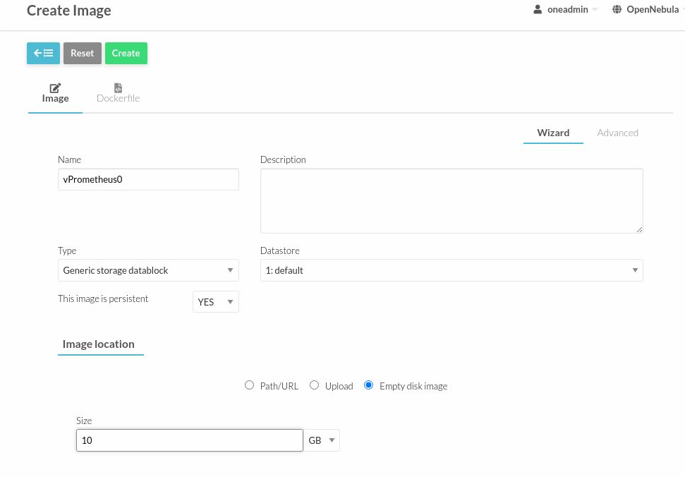

Figure 43 - Creating Virtual Hard Drive 1/2

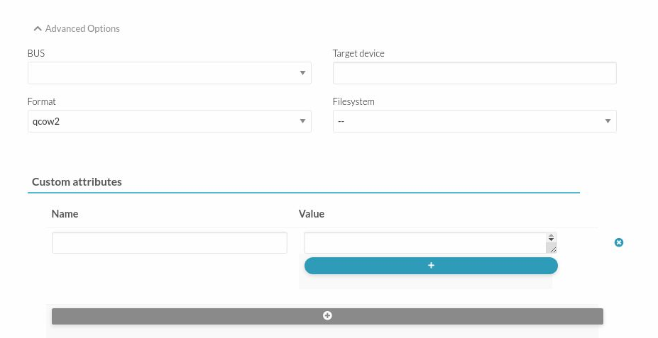

Figure 44 - Creating Virtual Hard Drive 2/2

After configuring the virtual network, I then moved onto creating the virtual hard drive which will be used to store the operating system and files. I created an empty 10GB generic storage data block and set the format to qcow2. I then named this vPrometheus0.

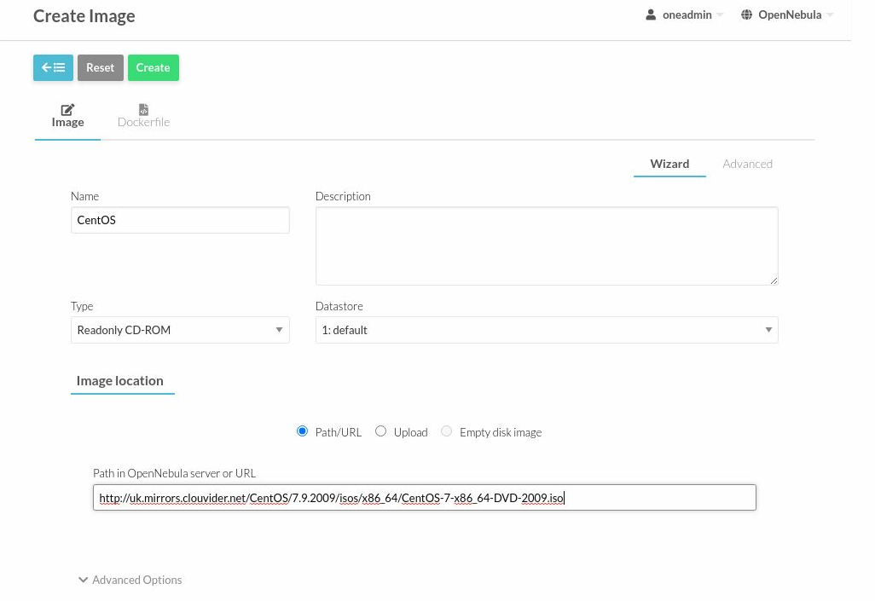

Figure 45 - Creating installation media

After creating the hard drive for the virtual machine, I created CentOS image. For this I copied the dvd link from a download and pasted this into the Path/URL section of the creation menu. I also set this to be Readonly CD-ROM as this isn’t persistent.

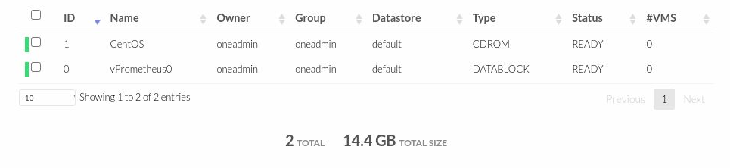

Figure 46 - Server Images

After waiting for the CentOS image to be downloaded to the Sunstone Server, both images then show as ready.

## Adding a Template

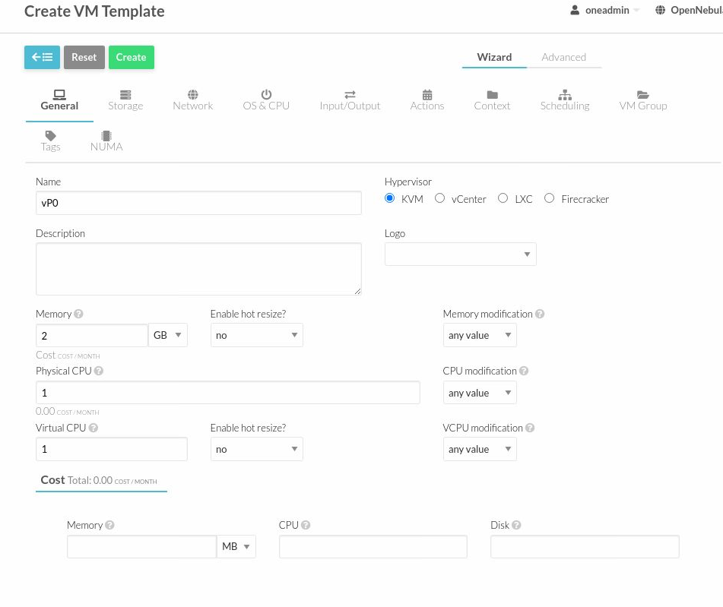

Figure 47 - VM Template (General)

In the general tab of the VM template creation, I set the name of the template to vP0, setting the hypervisor as KVM, and configuring 2GB of memory and 1 physical/virtual cpu.

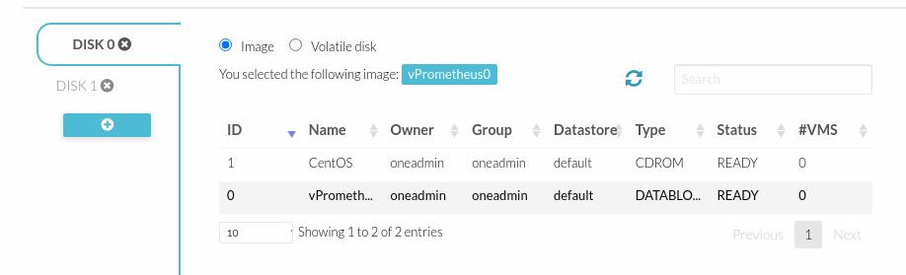

Figure 48 - VM Template (Storage DISK 0)

Selected vPrometheus0 for Disk 0, this will be the main disk used by the system

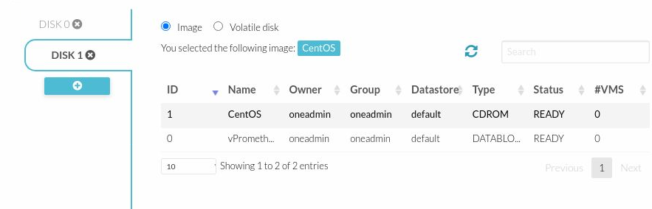

Figure 49 - VM Template (DISK 1)

Selected CentOS for Disk1, this will be used as the installation disk

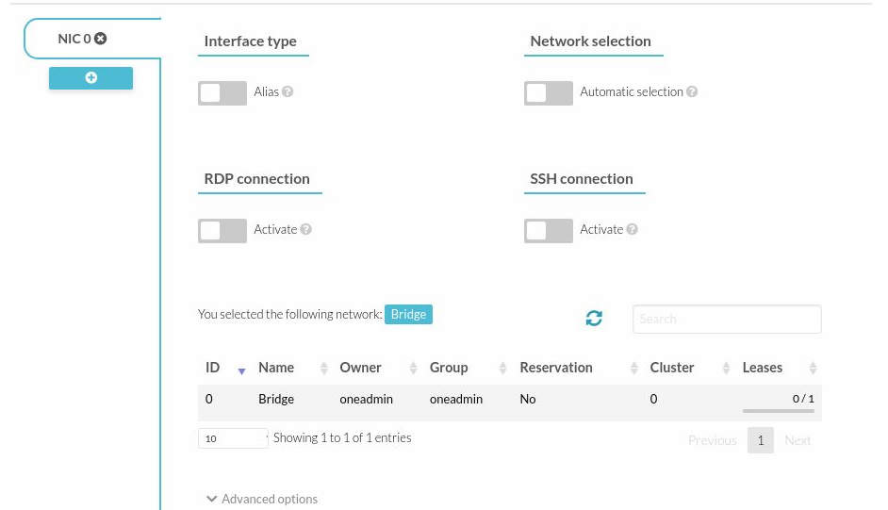

Figure 50 - VM Template (Network)

Moving into the Network tab, selected the Bridge virtual network previously created.

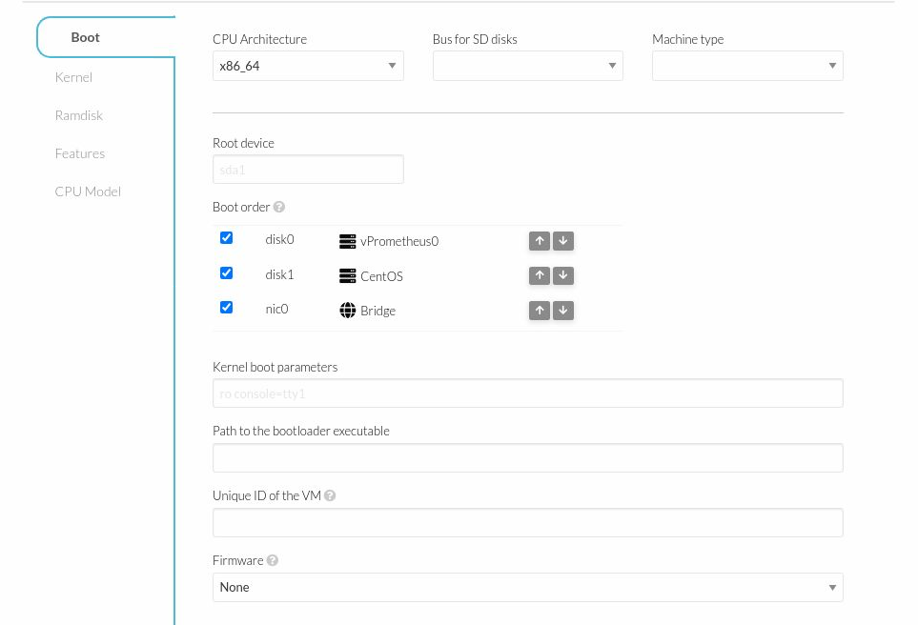

Figure 51 - VM Template (OS & CPU)

To match the CentOS image, I set the CPU architecture to x86_64 and set the boot order so that when Disk 0 has CentOS installed onto it, it will always be preferred over the installation media.

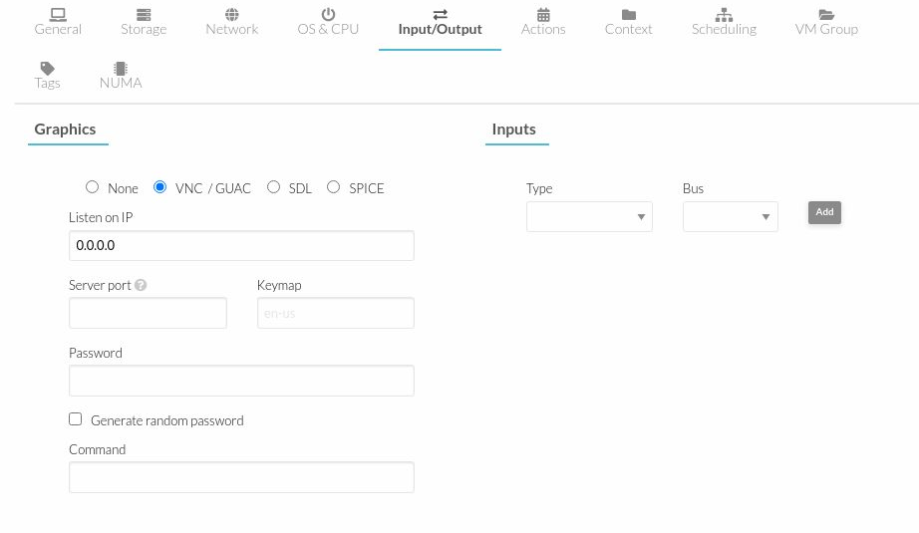

Figure 52 - VM Template (Input/Output)

For I/O, I left this as default VNC/GUAC

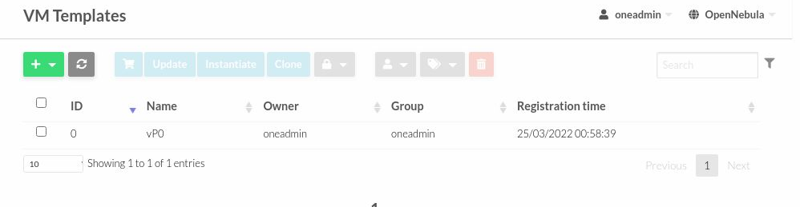

Figure 53 - Created vP0 Template

After finishing the configuration, I created the template. This is now ready to be used to setup a virtual machine.

## Adding a Virtual Machine

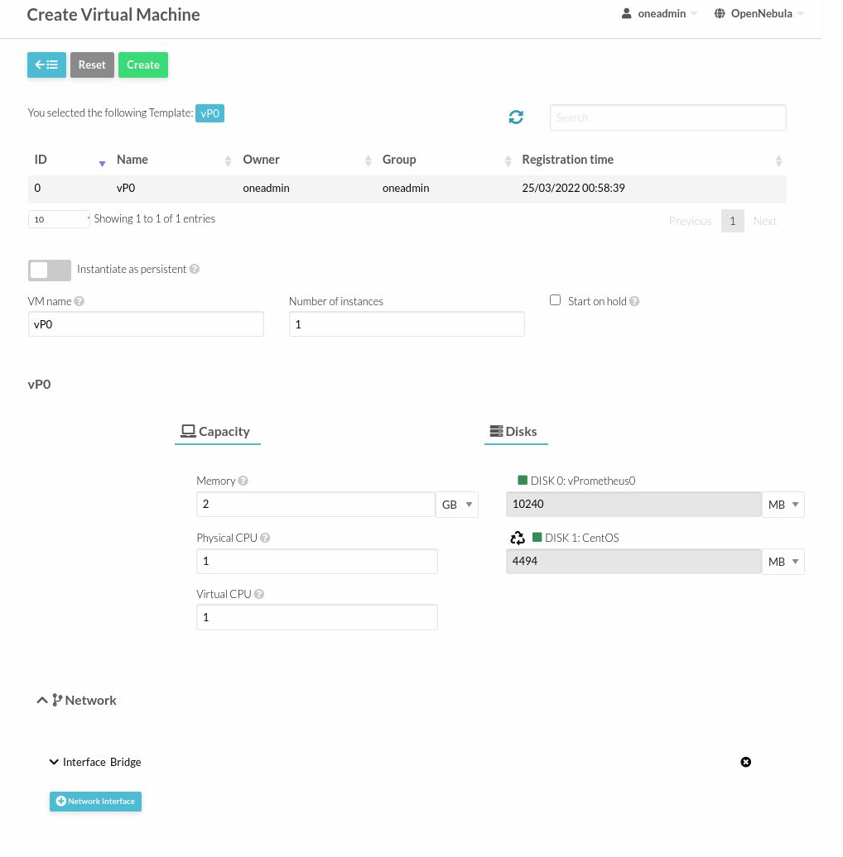

Figure 54 - Creating a Virtual Machine

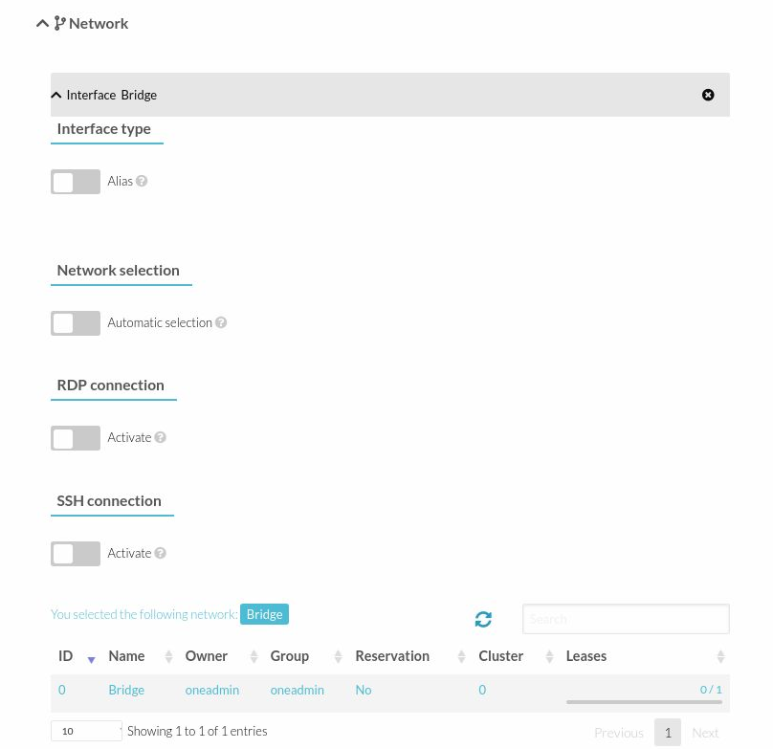

Figure 55 - Creating a Virtual Machine (Network Settings)

When creating the VM based off the template, I checked that all settings were correctly imported. The disk, memory, CPU and network settings were all correct.

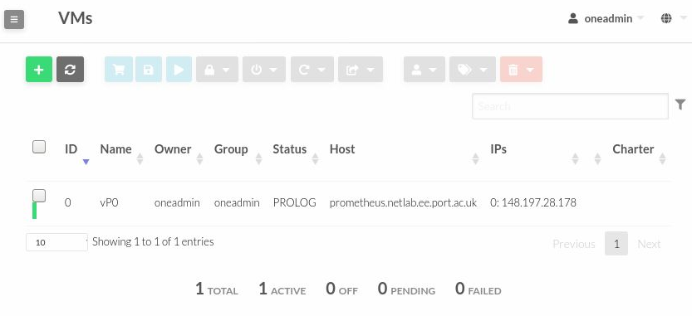

Figure 56 - VM in PROLOG

Once I created the virtual machine, the virtual machine entered the PROLOG state meaning it is transferring the virtual machine files to the host.

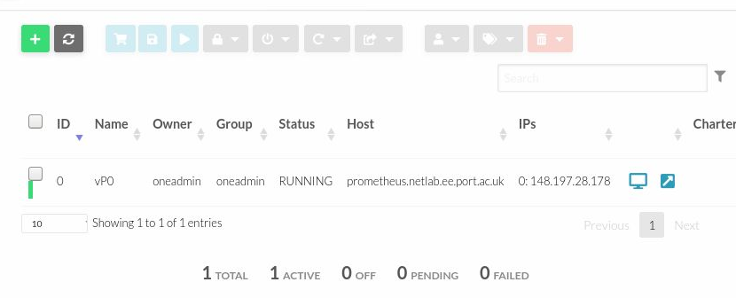

Figure 57 - Running VM

After about 10 seconds this changed to RUNNING, meaning it is now accessible through VNC (Virtual Network Computing)

VNC Virtual Machine Setup

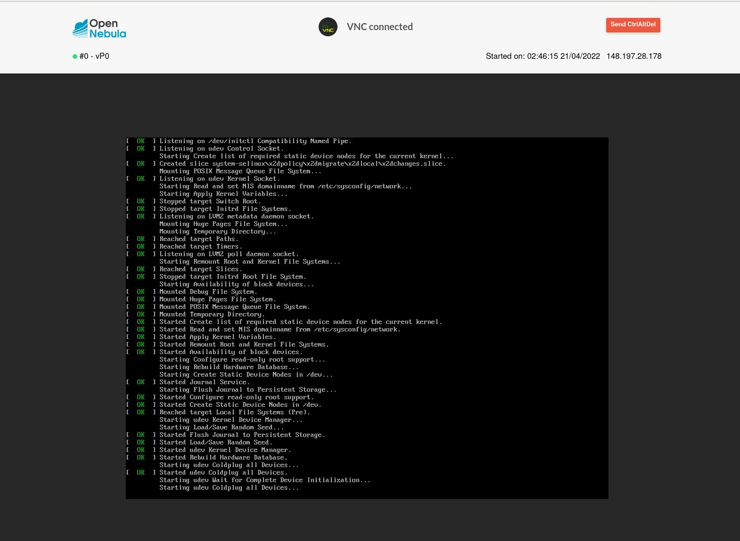

Figure 58 - Beginning CentOS Installation

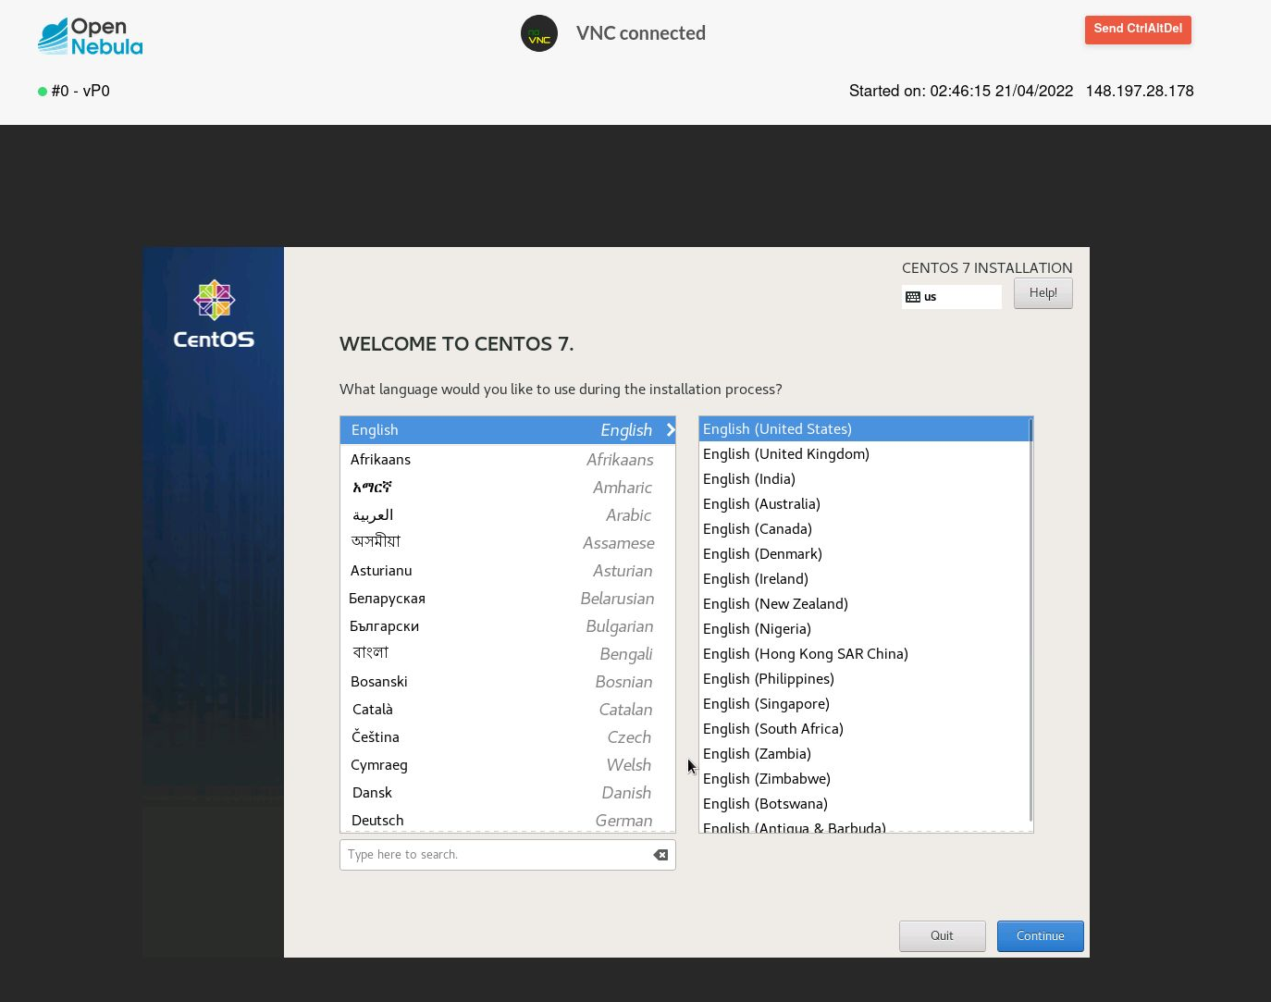

Figure 59 - Selecting VM Language

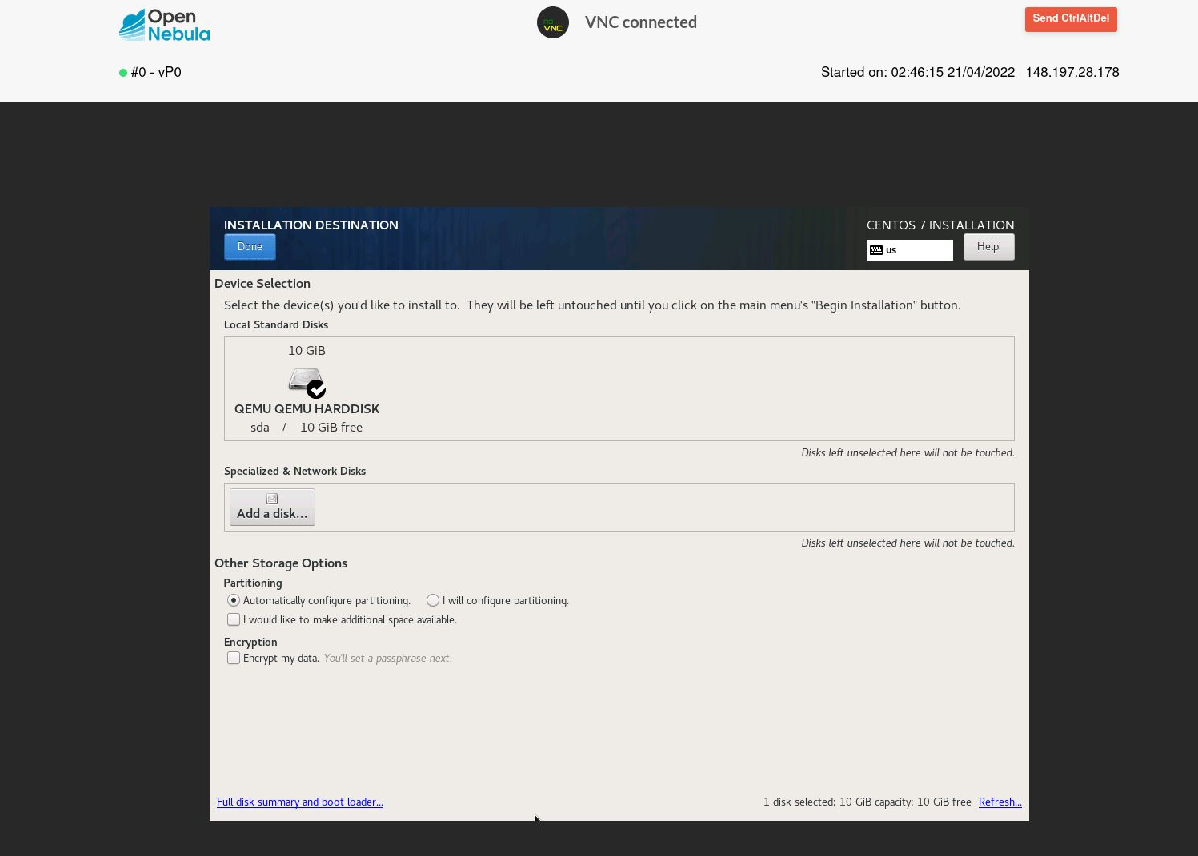

Figure 60 - Enabling Automatic Partitioning

In the hard drive section of the setup, I selected automatic partitioning and left other settings as standard.

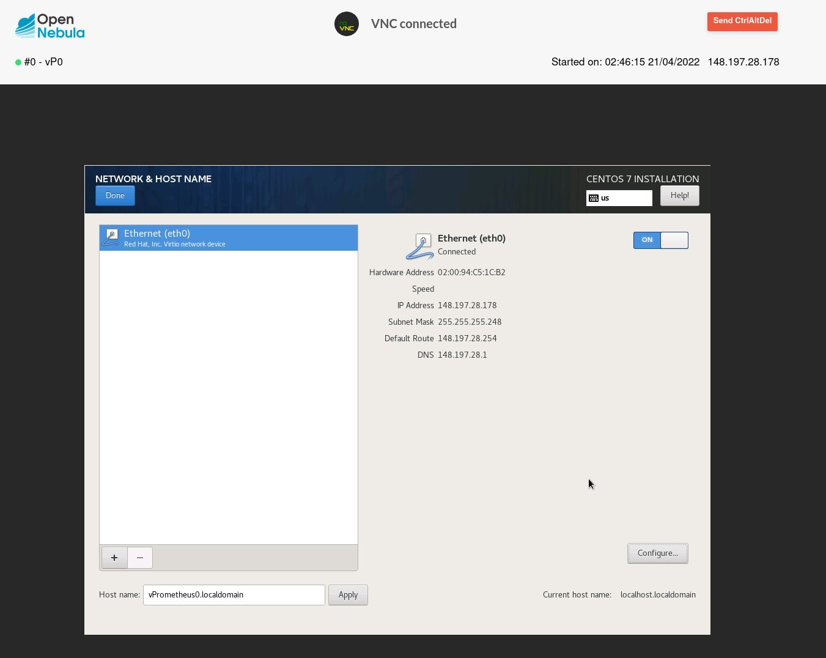

Figure 61 - Configuring Network Settings

Within the network settings I configured eth0 to match the network settings given the VM on my Open Nebula server. In this section I also changed the host name to vPrometheus0 to match the VM name vP0.

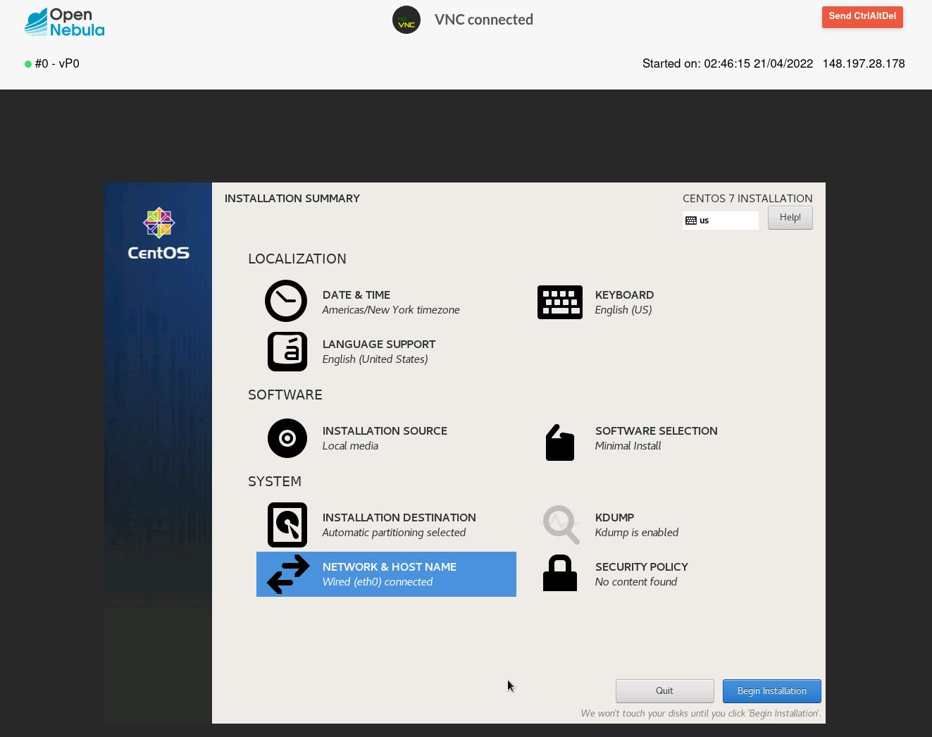

Figure 62 - Installation Summary

After all steps for installation were complete, I then clicked begin installation to start the process

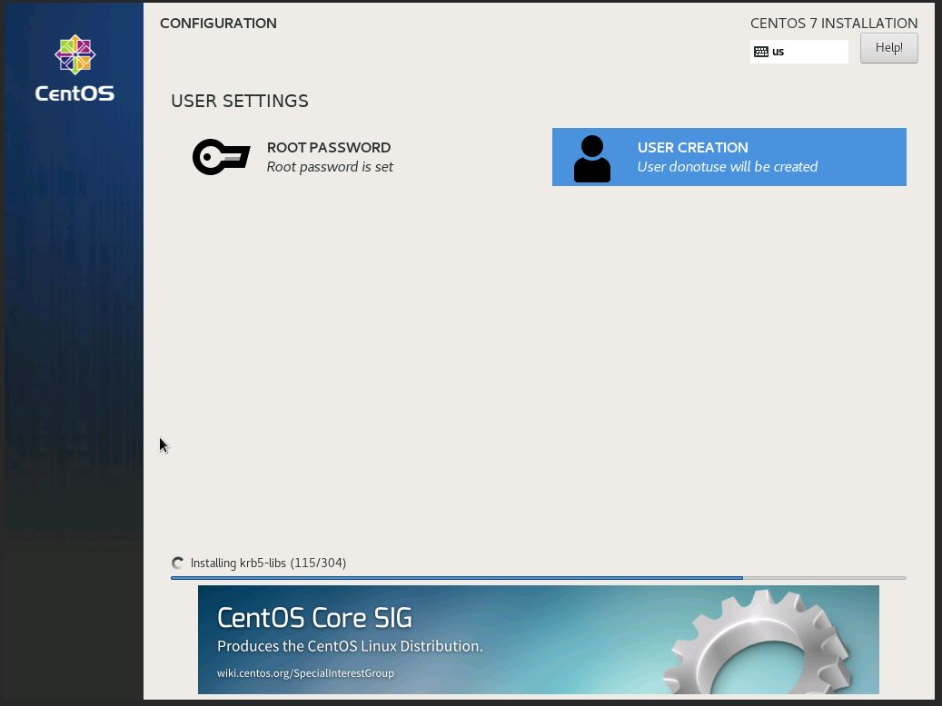

Figure 63 - User Settings

Whilst CentOS was installing, I filled out the root password and created a user for the server.

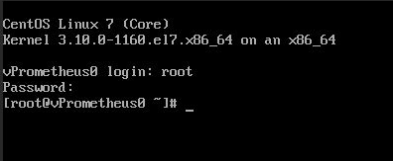

Figure 64 - CLI CentOS

Once installation was completed, I rebooted the VM and then logged into my root user with the username “root” and the password “localhost1”.

Installing GNOME Desktop

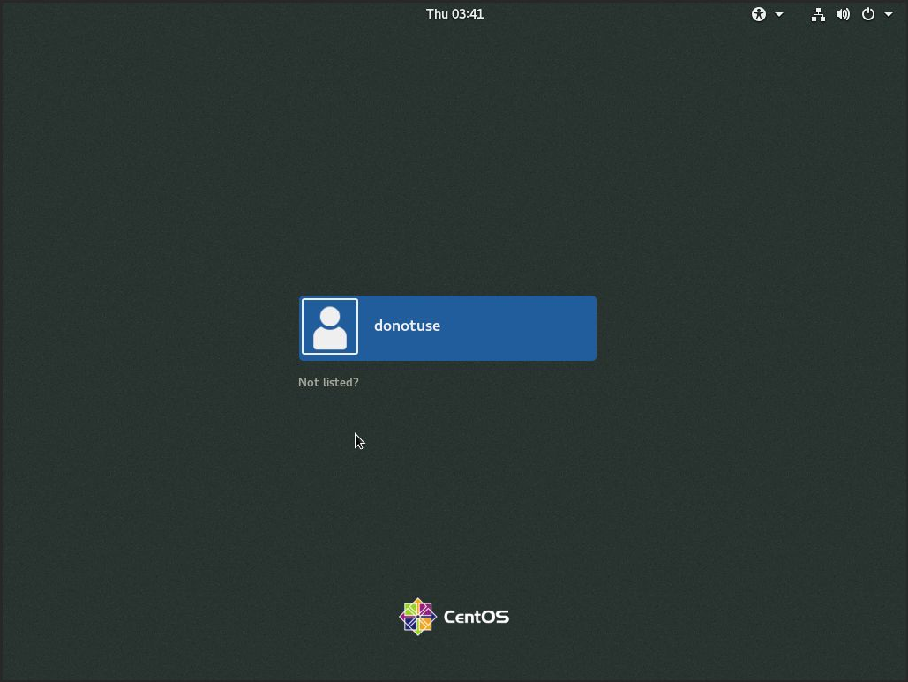

Figure 65 - Installed GNOME UI

During setup I forgot to select GNOME Desktop under the packages section, therefor, CentOS was installed as a minimal CLI installation.

To fix this I used two commands:

1. yum groupinstall "GNOME Desktop" "Graphical Administration Tools"

This will install the GNOME Desktop and the GUI version of all tools.

1. ln -sf /lib/systemd/system/runlevel5.target /etc/systemd/system/default.target

Using the above command forces the overwrite of the symlink /lib/systemd/system/runlevel5.target to /etc/systemd/system/default.target allowing graphical user interface.

1. Reboot

I then rebooted the system for this to take effect.

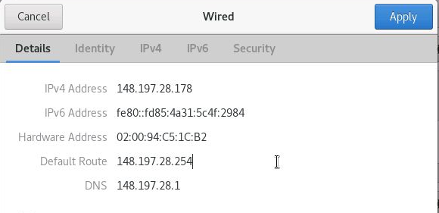

Figure 66 - Network Settings

# OVS Networking

## Installing OpenvSwitch

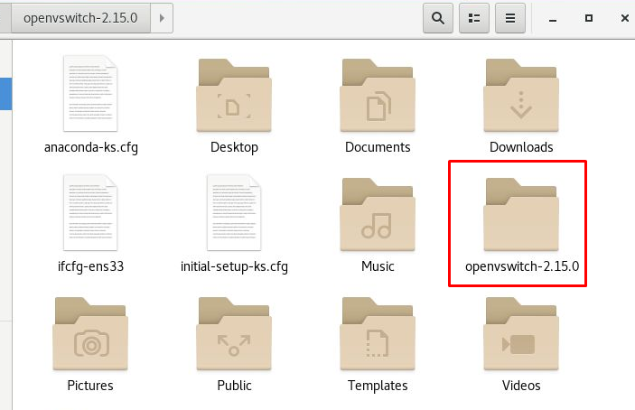

Figure 67 - Extracted openvswtich(Version 2.15.0)

I downloaded the OpenvSwitch tar file from the [OpenvSwitch downloads page](https://www.openvswitch.org/download/) and extracted this to my home folder. I then changed into the directory ready to begin creating the RPM.

### Installing Pre-Requisites

Before creating the RPM, I installed all the required pre-requisites. This includes the:

* Gcc compiler
* python, kernel, openssl and libtool development packages.
* Sphinx document building tool for python and python v3.6.0
* AutoConfiguration & Automake
* RPM-Build and RPM-Configuration

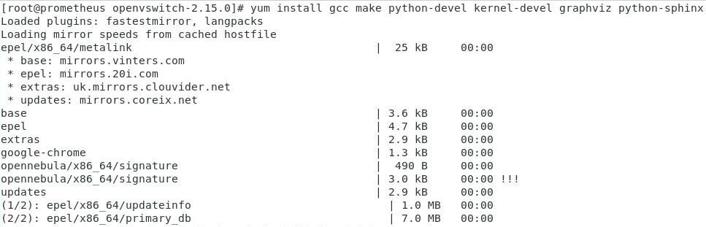

Figure 68 - Installing Compiler and development packages

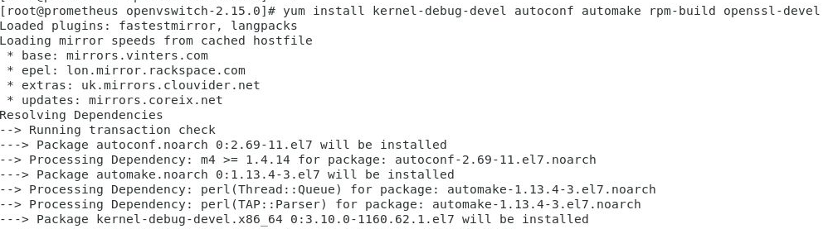

Figure 69 - Installing Automation Packages, Development packages and RPM Build

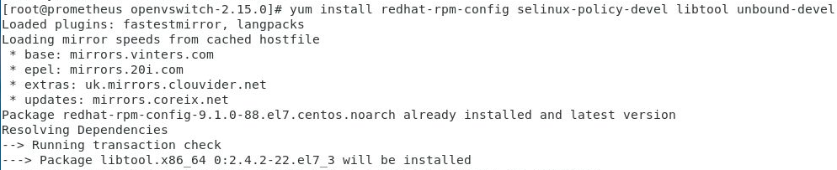

Figure 70 - Installing Development Packages & RPM Configuration

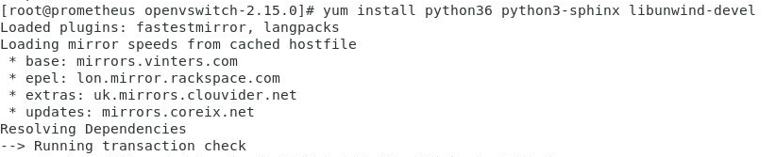

Figure 71 - Installing python 3.6.0, documentation builder & libtool development package

### Building Distribution Tarball

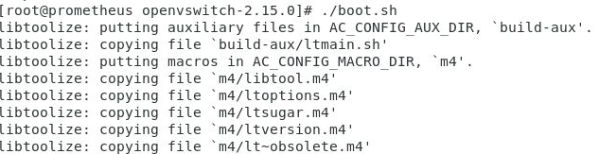

Figure 72 - Building Configure Script

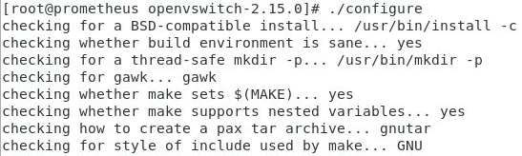

Figure 73 - Configuring the package

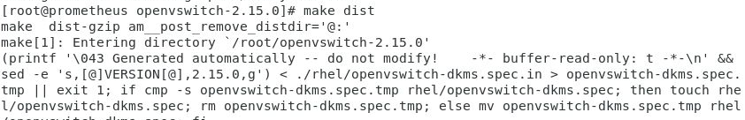

Figure 74 - Building Tarball Distribution

### Building RPM



Figure 75 - Creating rpm directories and copying tar file

I used mkdir -p ~/rpmbuild/{SOURCES,BUILD,RPMS,SPECS,SRPMS} to create fivee directories:

* SOURCES
* BUILD
* RPMS
* SPECS
* SRPMS

I then copied the tarball distribution into the sources folder.

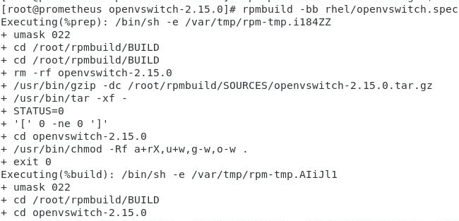

Figure 76 – Building OVS Userspace

After creating the directories and copying the tarball I remained in the same directory and ran the “rpmbuild” command to build the OpenvSwitch userspace. This creates three RPM’s openvswitch, openvswitch-devel and openvswitchdebuginfo.

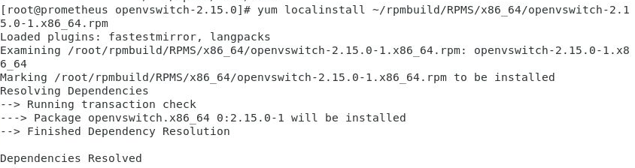

Figure 77 - Installing OVS

Taking the newly created RPM from “~/rpmbuild/RPMS/x86_64/openvswitch-2.15.0-1.x86_64.rpm” I installed the rpm using the “localinstall” command rather than using “rpm -i” to avoid any dependency issues.

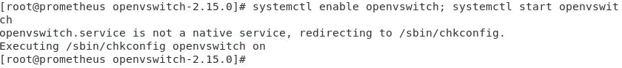

Figure 78 - Starting OVS & Enabling Autorun

After installing the OVS RPM, I started OVS and enabled it to run each time the system is booted.

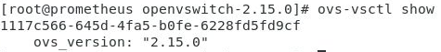

Figure 79 - Checking install

“ovs-vsctl show” displays the version number showing the OVS has successfully been installed on the system.

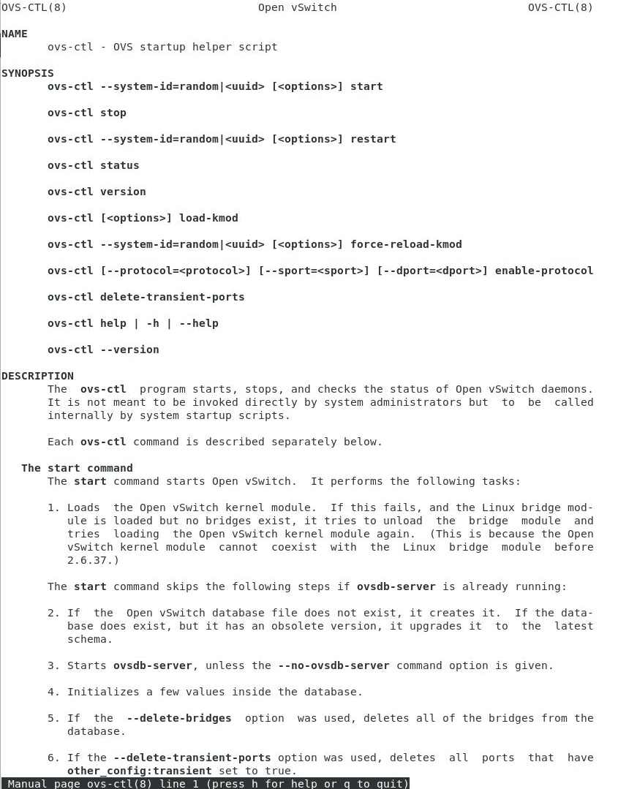

Figure 80 - OVS Manual Page

Man ovs-ctl displays commands which can be used with OVS

## OVS Configuration

### Reverting Network Settings

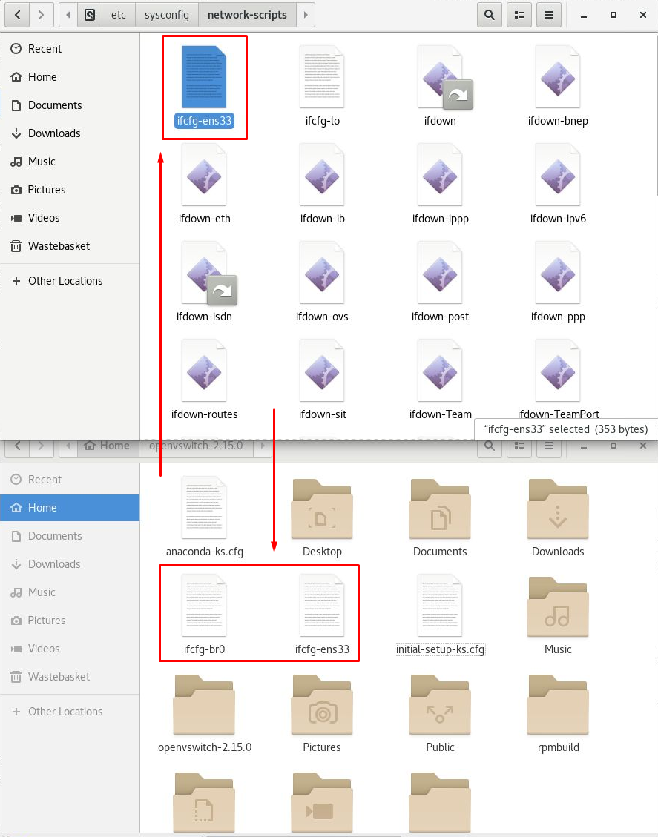

Figure 81 - Reverting Network Settings

Before configuring OVS, I reverted the network settings by removing the edited ifcfg-ens33 file and br0 file from /etc/sysconfig/network-scripts and placing them in the ~/home folder, replacing them with the original ifcfg-ens33 file.

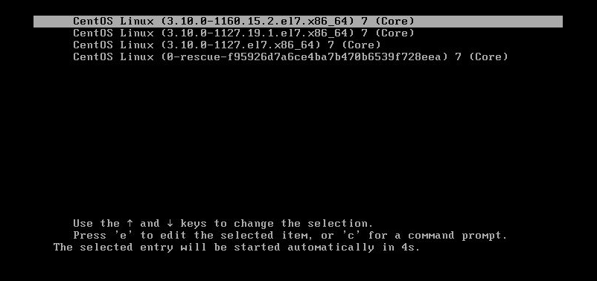

Figure 82 - Rebooting Host

I then rebooted the virtual machine to reconfigure the network settings.

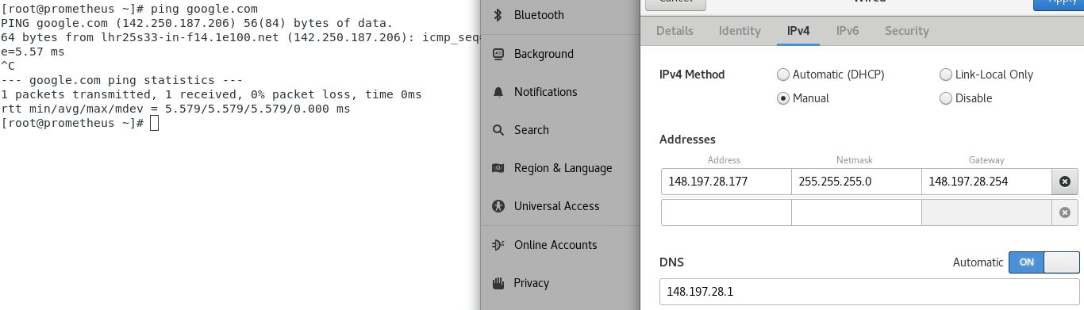

Figure 83 - Testing Reverted Settings

Once logged into the system I then reconfigured my adapter and tested the network connection.

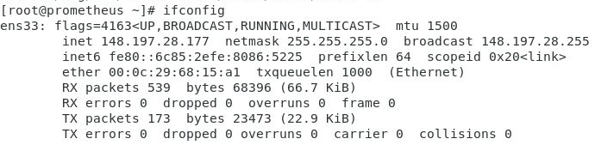

Figure 84 - Re-Using Ens33 Adapter

This is now using the ens33 adapter again instead of the custom br0

### Configuring New Network

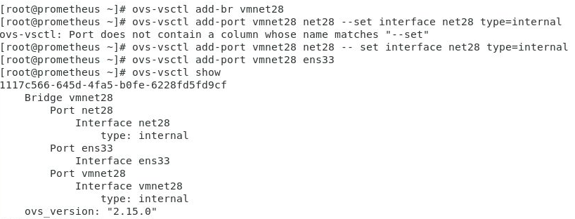

Figure 85 - Creating Bridges & Ports

I created a bridge called vmnet28, I named it this as I am on the .28 network. I then created two ports, net28 and ens33 setting the interface for vmnet28 as net28.

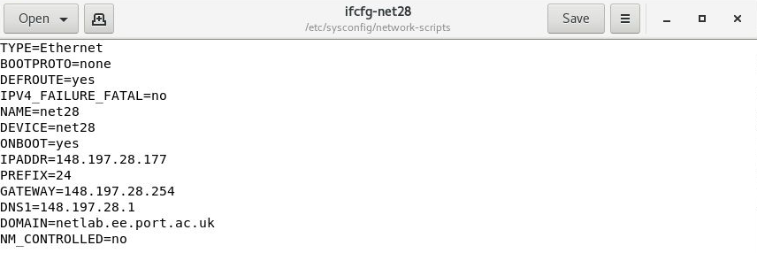

Figure 86 - Creating ifcfg-net28 file

I then created the ifcfg-net28 file, altering the name and device to net28 and changing ipaddr, gateway and dns1 to match Prometheus’s network settings.

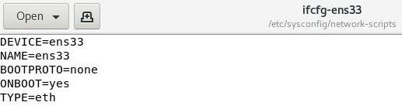

Figure 87 - Altered ifcfg-ens33 file

Altered the ens33 file

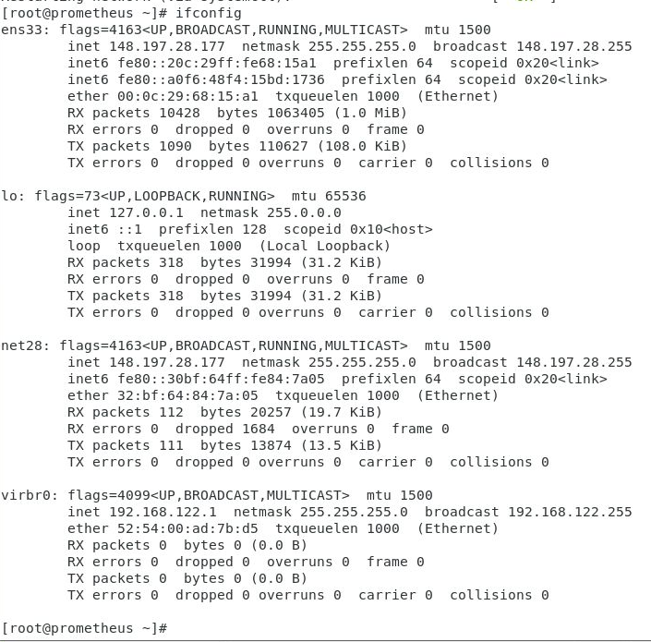

Figure 88 - Network Configuration

Using “service network restart” I restarted the network settings, entering ifconfig then shows the new net28 adapter with the same network settings as the ens33 adapter.

### Creating Extra Networks

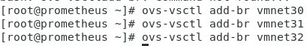

Figure 89 - Adding vmnet30-32 bridges

Using the same command as before I added bridges vmnet 30 through 32.



Figure 90 - Adding net30-32 ports | Setting net30-32 interfaces

Similarly, I also added the ports for each of these bridges, setting the interfaces for them as net30-32.

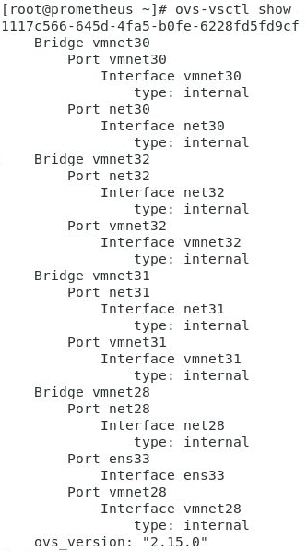

Figure 91 - Final OVS network setup

After adding the new bridges and ports, I then used the “ovs-vsctl show” command to check the OVS Network was configured correctly.

### Configuring ifcfg30-32

When configuring the new files, I copied the previously configured ifcfg-28 file, renaming each new file according to the network and changing NAME, DEVICE and IPADDR within each new file.

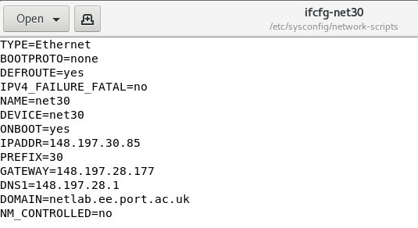

Figure 92 - New ifcfg-net30

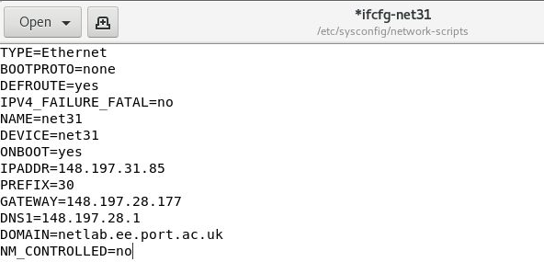

Figure 93 - New ifcfg-net31

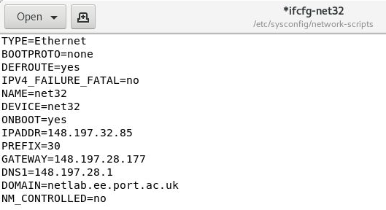

Figure 94 - New ifcfg-net32



Figure 95 - Restarting network

Restarting the network shows there are no issues with the configuration files.

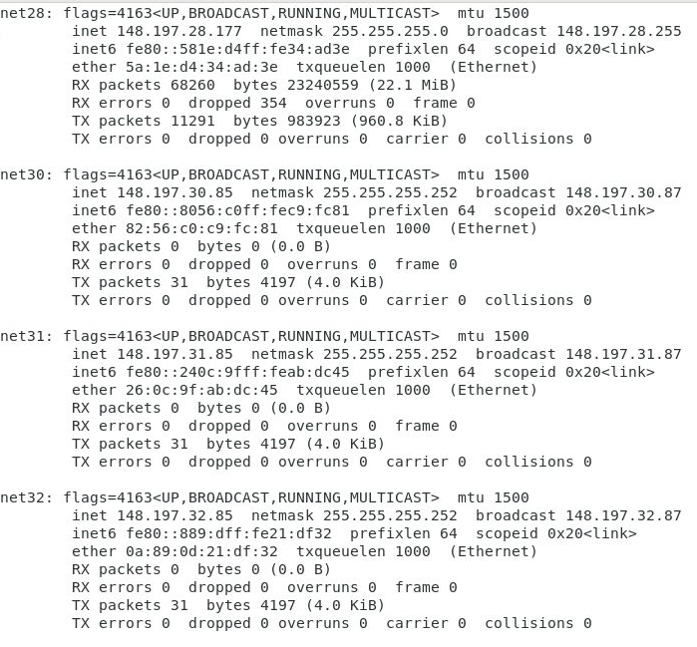

Figure 96 - Custom Network Interfaces

After restarting the network, all network interfaces are displayed with the correct IP, subnet and broadcast addresses when using the ifconfig command

## Networking in the cloud

In this section I will be configuring the cloud networks for net 28-32.

### Net 28

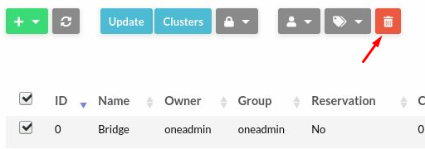

Figure 97 - Deleting old Bridge Network

As I am no longer using the bridged network, I can delete this from the virtual networks section of Open Nebula so it can be replaced by my net28.

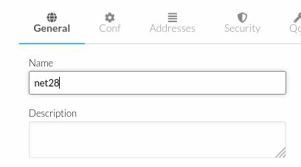

Figure 98 - New Net28 Network

The setup processes the same as setting up the bridged adapter, firstly within the general tab, I set the name of the virtual network as net28.

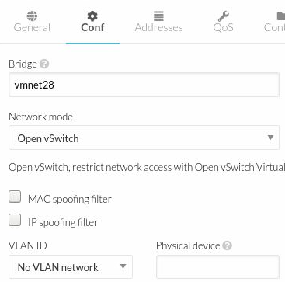

Figure 99 - Net28 (Conf)

Next, within the conf tab I set bridge to vmnet28 and changed Network Mode to Open vSwitch since this has now been setup.

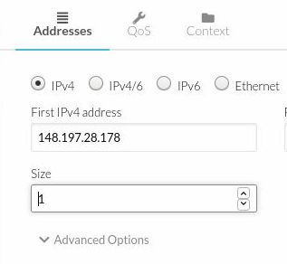

Figure 100 - Net28 Addresses

Within the addresses tab, I set the First usable IPv4 address. Since this machine is bridged, this IP address is the host machine, Prometheus, plus one (148.197.28.177+1). I also set the network size to one as this network will only use 1 address.

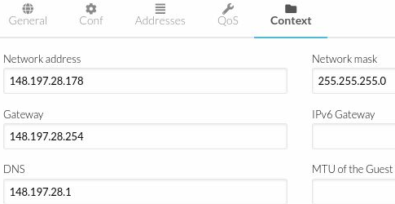

Figure 101 - Net28 (Context)

Within the context tab I then further configured the network settings of the virtual network, inserting the Gateway, network mask and DNS.

### Configuring Net30-32

These virtual networks are configured in the same way as net28. Following the data present in the ifcfg files of each network. Within the Addresses section for each of these I set this as 5 as I will have multiple machines running within the cloud environment on the same networks.

#### Net 30

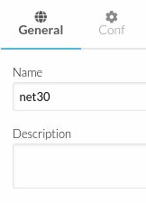

Figure 102 - Net30 (General)

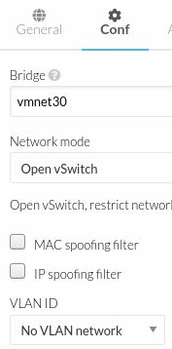

Figure 103 - Net30 (Conf)

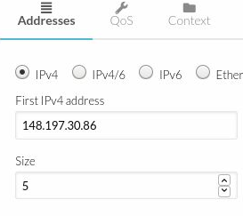

Figure 104 - Net30 (Addresses)

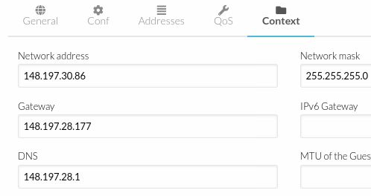

Figure 105 - Net30 (Context)

#### Net 31

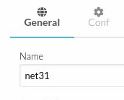

Figure 106 - Net31 (General)

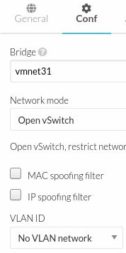

Figure 107 - Net31 (Conf)

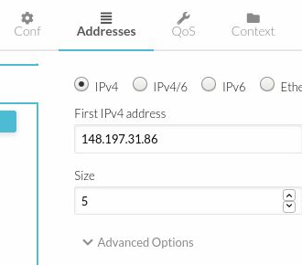

Figure 108 - Net31 (Addresses)

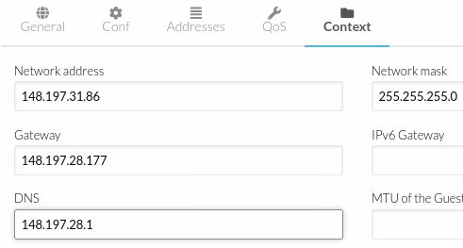

Figure 109 - Net31 (Context)

#### Net 32

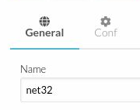

Figure 110 - Net32 (General)

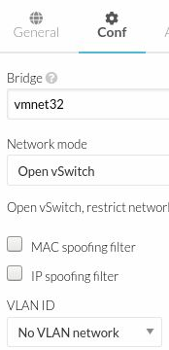

Figure 111 - Net32 (Conf)

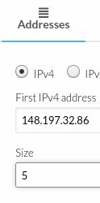

Figure 112 - Net32 (Addresses)

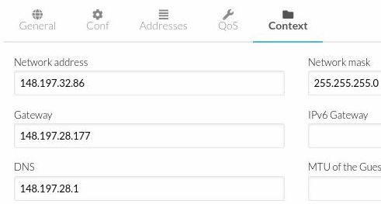

Figure 113 - Net32 (Context)

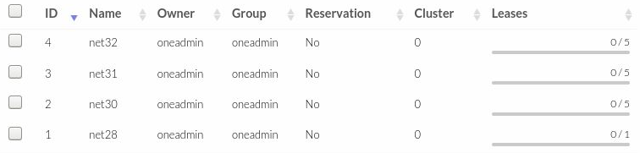

Figure 114 - Net28-32 Virtual Networks

After configuring all networks, these then show up in the virtual network’s menu displaying how many virtual machines they are leased to.

## Dynamic Routing

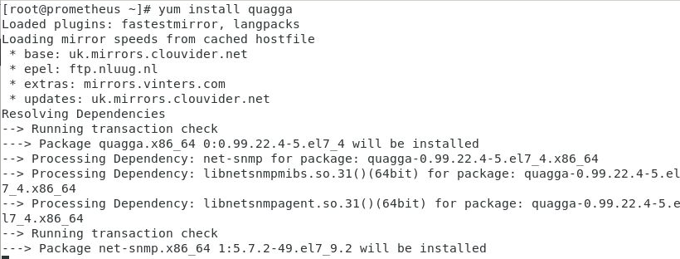

Figure 115 - Installing Routing Software

To begin dynamic routing, I installed the quagga routing software, used for Open Shortest Path First(OSPF) which will be used for the cloud networks

### Ospf.conf Configuration

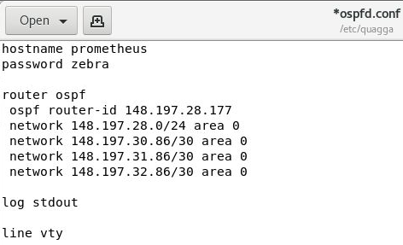

Figure 116 - ospfd.conf file configuration

To configure ospf, all networks and their addresses must be manually entered into the ospfd.conf file.

### Zebra.conf configuration

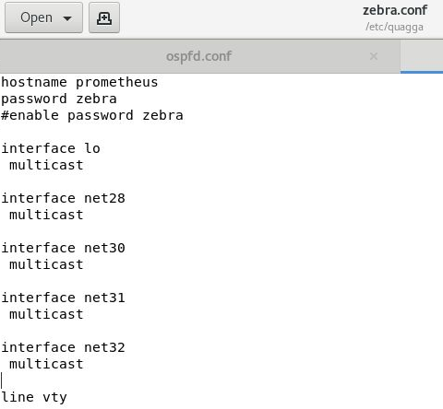

Figure 117 - zebra.conf file configuration

zebra.conf is the configuration file used for the zebra routing manager daemon. This file will contain all network interfaces that quagga will use for routing the network.

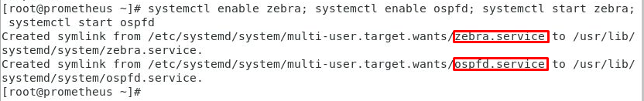

Figure 118 - Starting Zebra/Ospfd | Enabling Automatic Start

I then started both the ospfd and zebra services and using the enable command allowed them to run automatically whenever the system is booted.

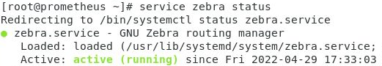

Figure 119 - Zebra service active (No Errors)

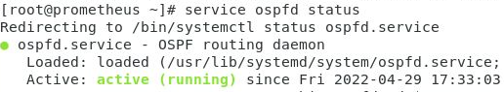

Figure 120 - Ospf service active (No Errors)

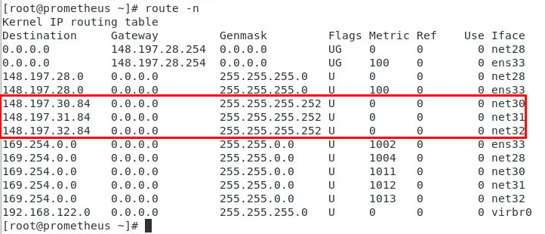

Figure 121 - Routing table (Prometheus)

Now that routing is setup on promethus, using route -n to display the routing table, net28-32 can be seen within the routing specification.

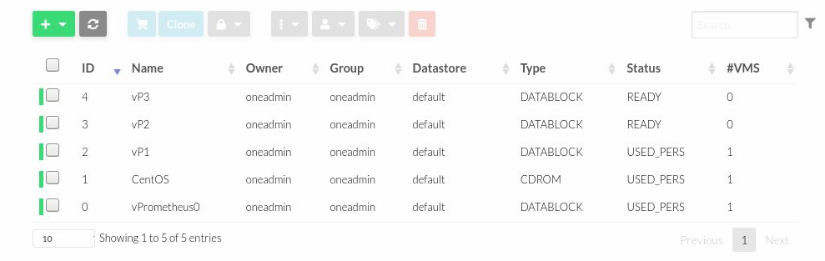

Figure 122 - Created Virtual Drives

Following the same steps as before I created new virtual drive for each of the virtual machines which will be allocated to the new virtual networks created.



Figure 123 - Removing installation media

After installing CentOS on the previous machine, I powered off the VM and detached the installation media from the VM, allowing me to use it for the next installation.

Installing CentOS

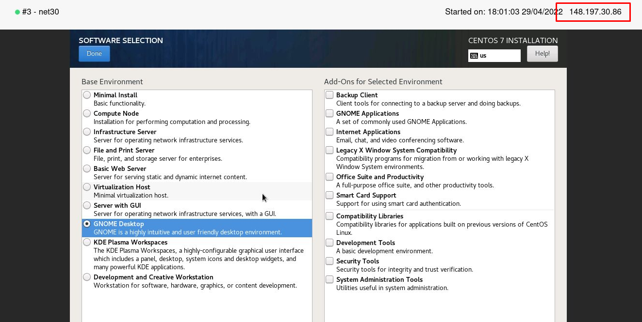

Figure 124 - Software Selection

Within the setup, under the software selection menu, I selected GNOME Desktop to provide a graphical interface on the net30 virtual machine.

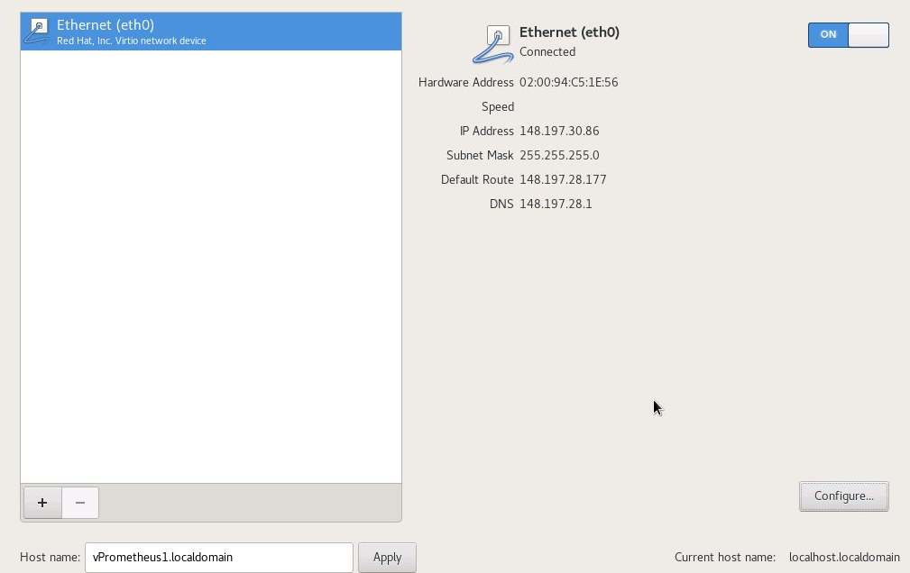

Figure 125 - Network Setup

I then moved into the network configuration section, setting the host name as “vPromtheus1.localdomain” and configuring the network settings to match those stored in the OVS document.

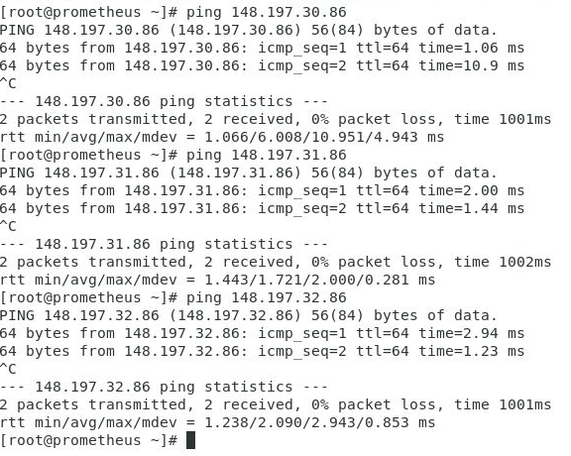

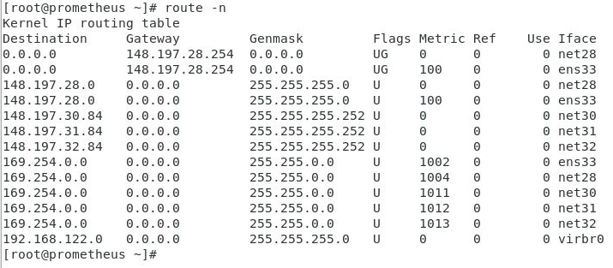

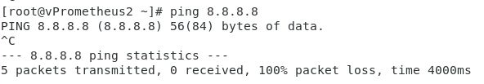

No internet connection due to a NAT issue in VMWare.

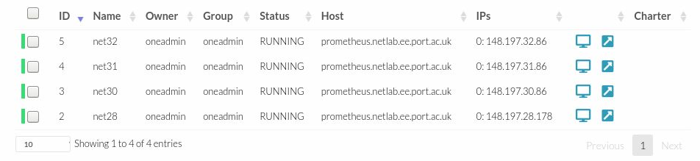

Figure 126 - Running Virtual Machines

Following the same process, I continued to setup both net31 and net 32, both with the same operating system and GNOME Desktop.

# Populating the Cloud

## Open Nebula Marketplace

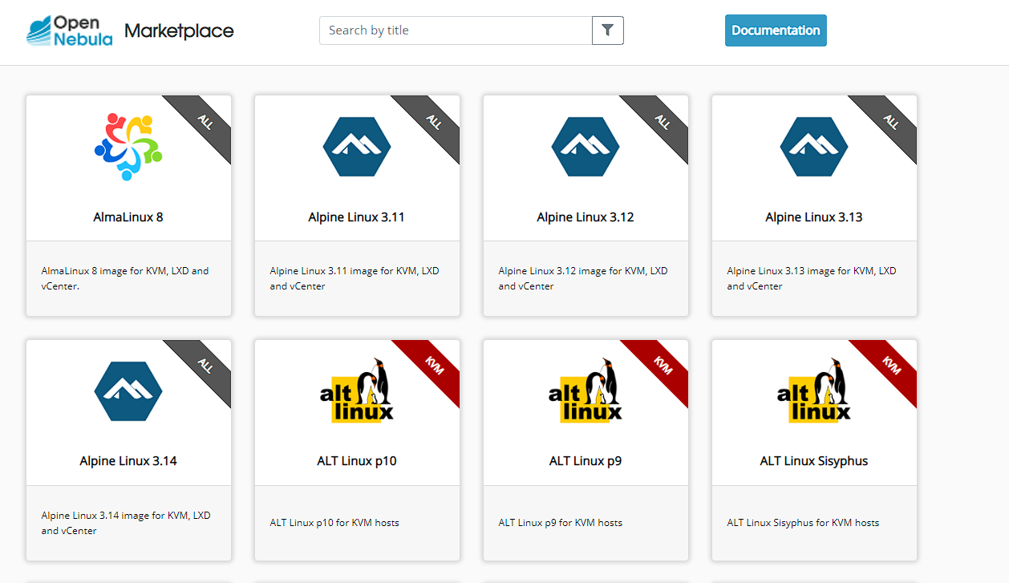

Figure 127 - Open Nebula Marketplace

Within the Open Nebula Marketplace there is a wide selection of pre-built virtual machines to choose from. These range an empty disk for custom installation of an operating system to up-to-date CentOS, Debian and Ubuntu installations.

## Creating Users, Groups and VDC

Explain the VDC blah blah blah IDFK

### VDC

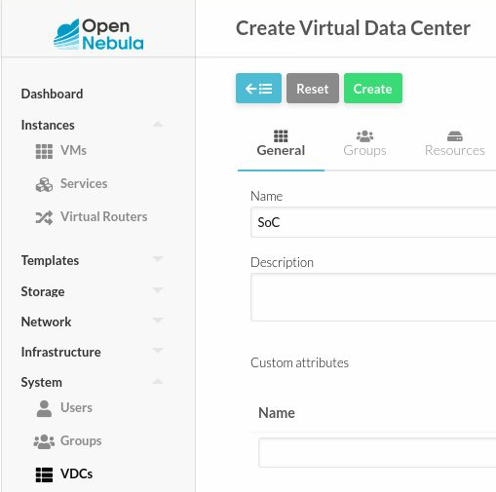

Figure 128 - Creating VDC

In open nebula, I navigated to the VDC’s tab within the system drop down. In VDC I chose to create a new VDC and in the general tab named this SoC for School of Computing.

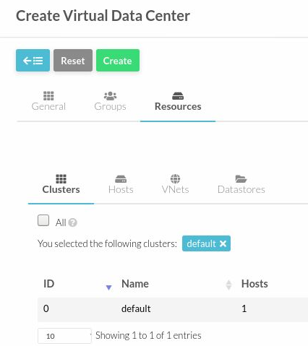

Figure 129 - Configuring VDC Cluster

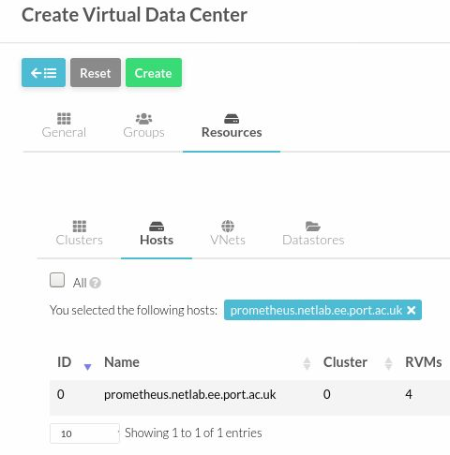

Figure 130 - VDC Hosts

Next in Resources>Hosts I selected the Prometheus host previously created.

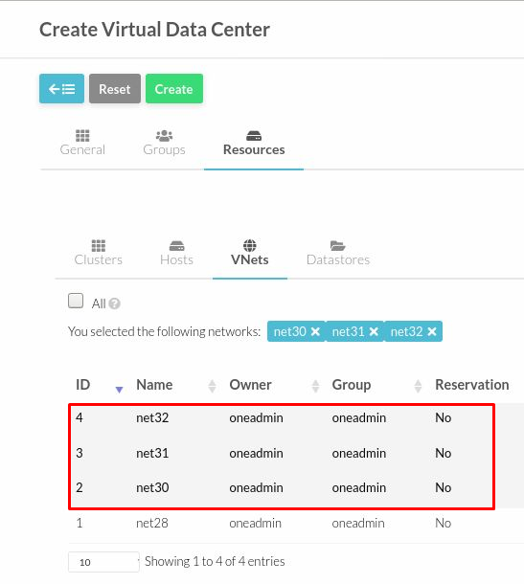

Figure 131 - VDC VNets

I then selected net30,31 and 32 to associate them with the VDC. These are the networks which will be used for the file server, lecturer clients and student clients.

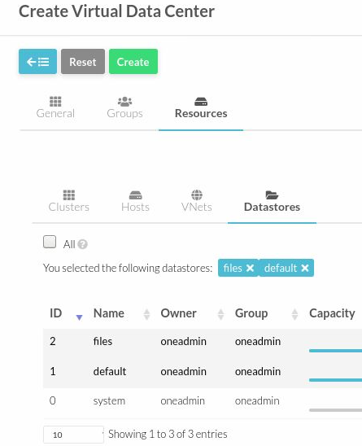

Figure 132 - VDC Datastores

### Admin User

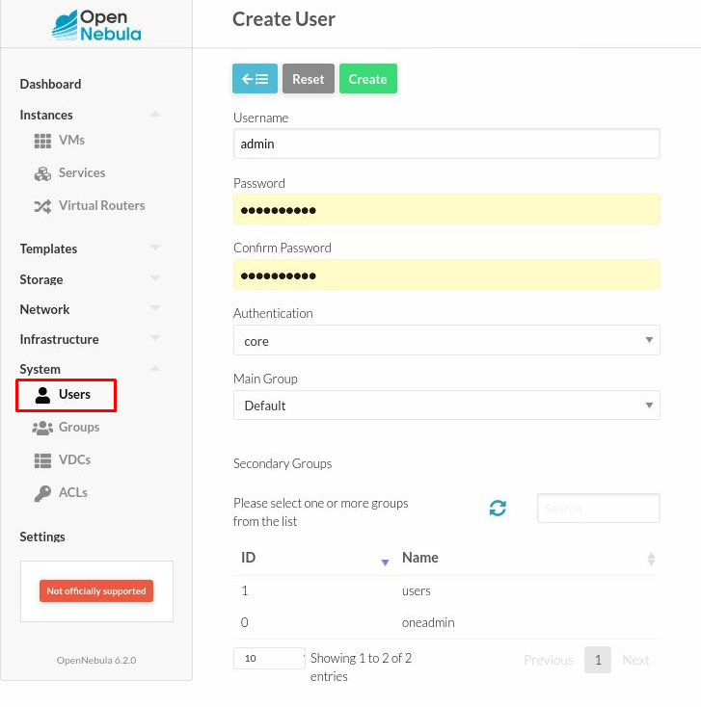

Figure 133 - Creating Admin User

Firstly, within the Users tab, I created the admin user for the SoC Cloud.

### Teachers Group

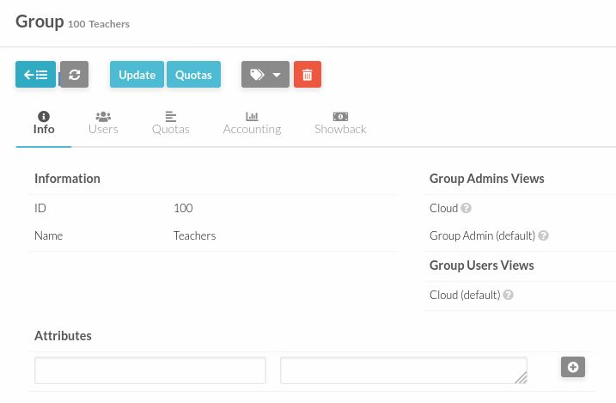

Figure 134 - Creating Teachers Group

### Students Group

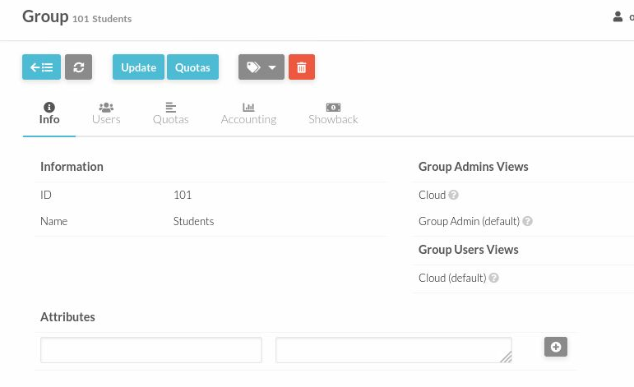

Figure 135 - Creating Students Group

### Updating VDC

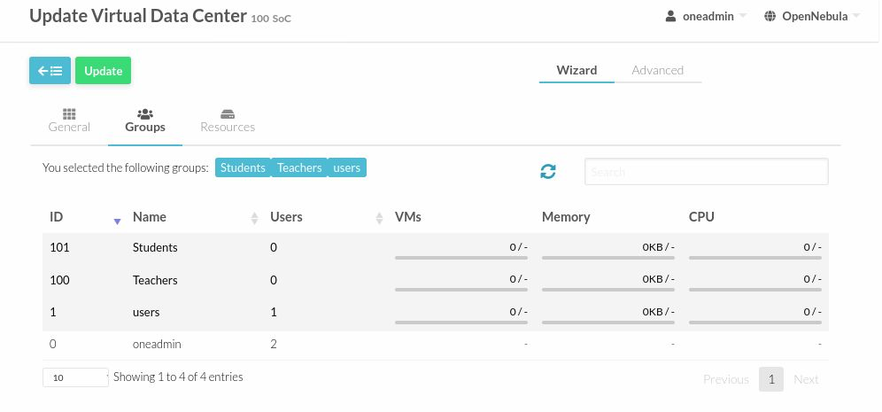

Figure 136 - Updating VDC

After creating the groups and admin user, I then added these to the VDC, these can then be monitored showing how many vm’s are being used along with the statistics of system resources.

## Creating VFS Virtual Machine

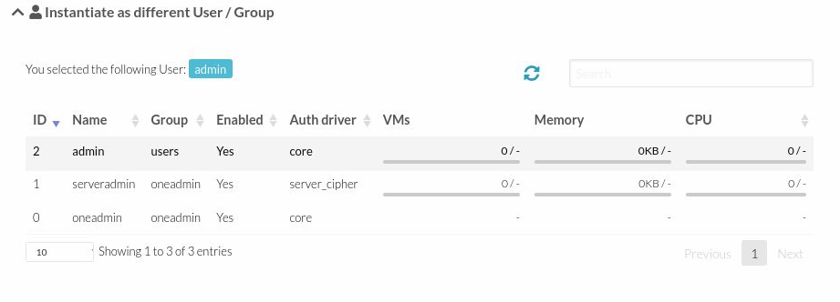

Figure 137 - Adding admin to VM user/group

Following the same steps as creating the previous virtual machines, I created the file server, allocating it to net30 and user admin.

### CentOS Installation

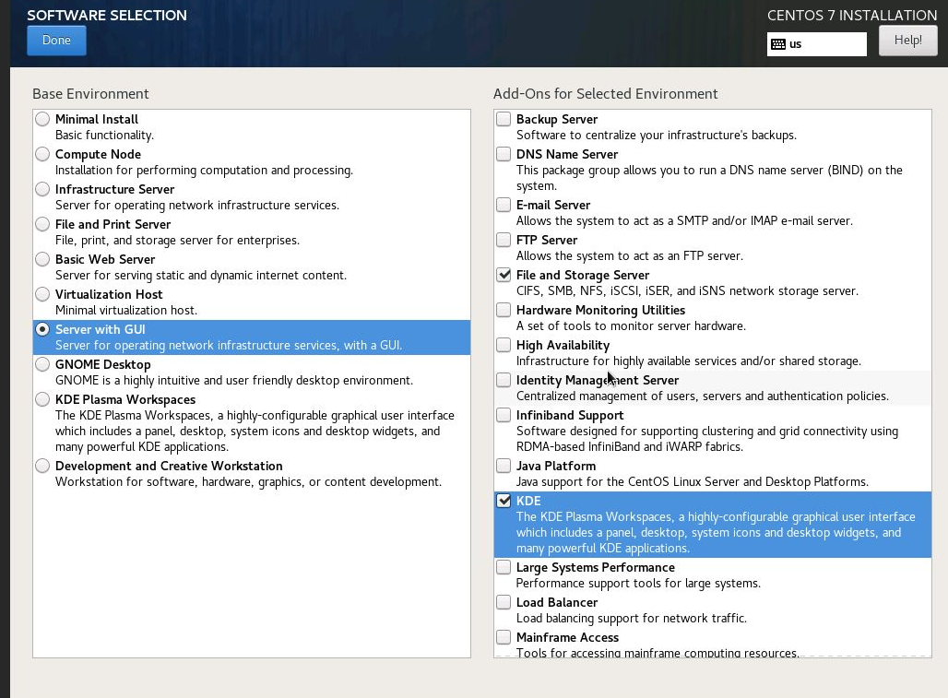

Figure 138 - Software Selection

During the setup, I selected server with GUI within the software selection portion of the installation. This allowed me to install the File and Storage server package along with the KDE GUI.

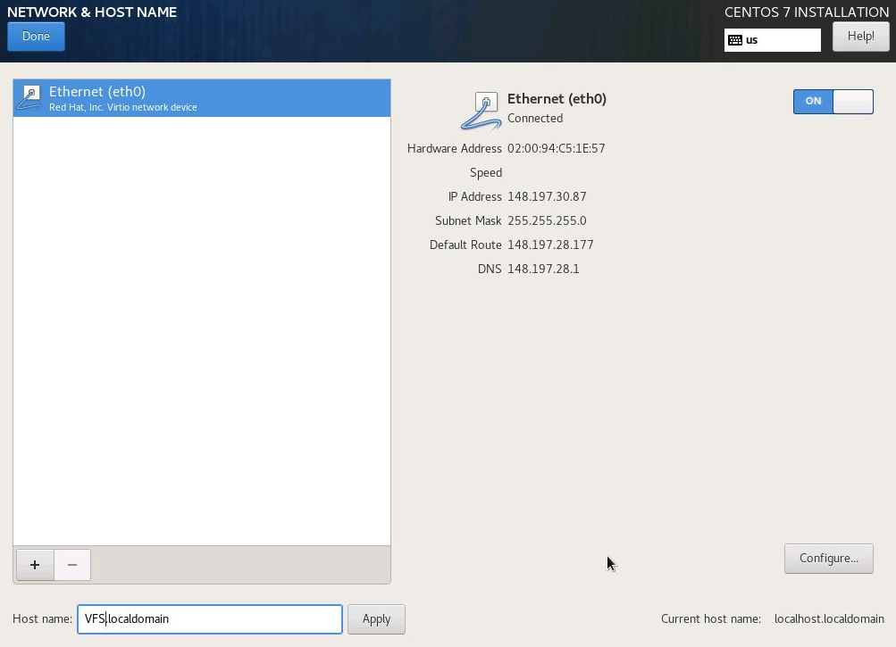

Figure 139 - Network Setup

I then setup the network adapter according to the settings used within Open Nebula.

## Setting up NFS

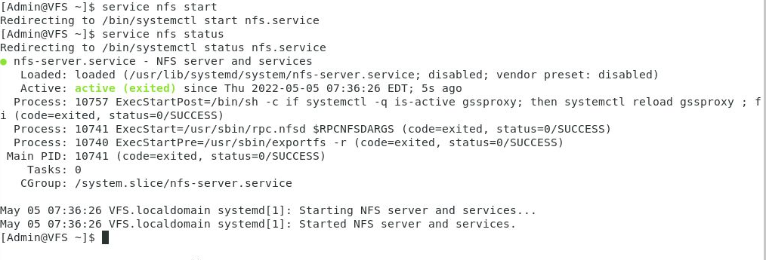

Figure 140 - Starting NFS Service

Once logged in, I started the NFS Service, which returned no errors showing everything was working as expected.

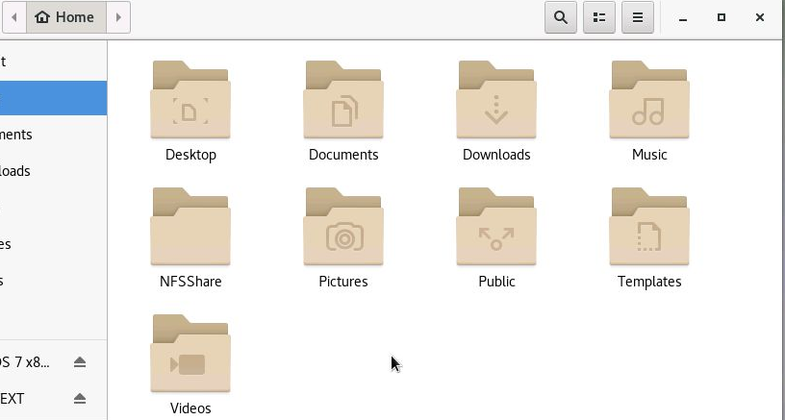

Figure 141 - Creating Shared Folder

With NFS running in the background, I created my folder which will be shared in the home directory on the file server.

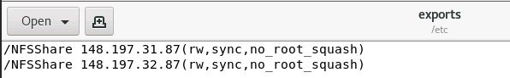

Figure 142 - Creating Exports File

I then created the exports file, including the path to the shared folder along with IP Addresses which will have access to it and the permissions. RW meaning that the client will have both read and write, along with no_root_squash which allows the root user to access the shared folder.

### Chosen Workstation Installation

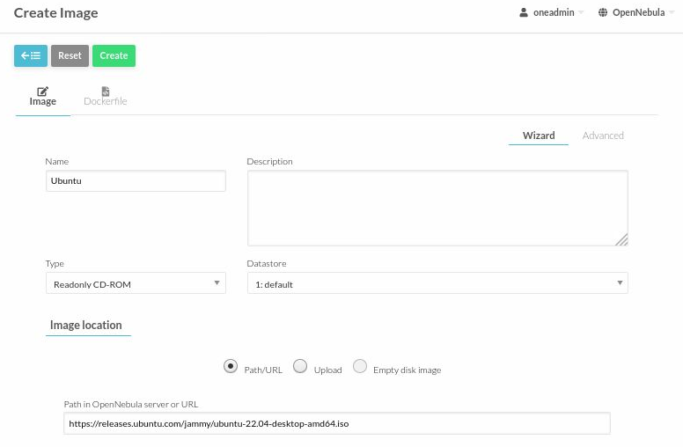

Figure 143 - Creating Ubuntu Installation Media

I chose to create an Ubuntu 22.04 image for use with installing ubuntu on the teacher and student machines. I chose this method as I felt it would give me more control over the system since I could build it myself over a prebuilt solution from the Open Nebula Marketplace.

### Creating Teacher Virtual Machines

#### Creating image

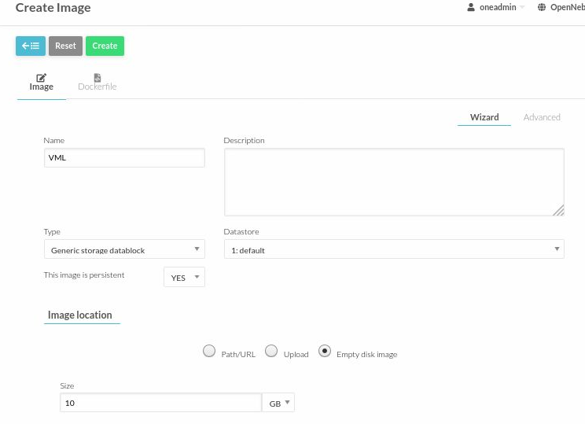

Figure 144 - Creating Lecturer Storage

When creating the storage media for the lecturer, I chose to use persistent storage as teachers will need their own workspace for permanent files. For example, these may contain sensitive information and therefore should not be stored on the cloud, which they will also have access to. For the format I selected qcow2, the same as all other virtual machines.

#### Creating Template

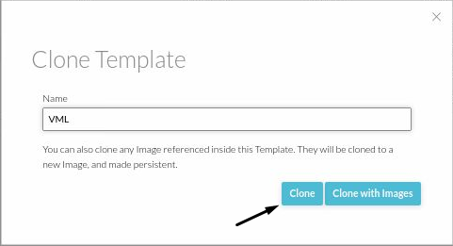

Figure 145 - Copying VP2 Template for VML

I cloned the vp2 template and renamed it to VML as this is pre-configured exactly how I want it bar from the disks and group ownership which I will change.

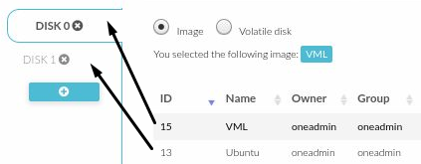

Figure 146 - Altering Storage

Moving to the storage tab, I changed DISK 0 to use the new VML image for storage and DISK 1 to use the Ubuntu installation media.

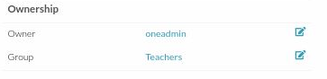

Figure 147 - Changing ownership

I then assigned the Teachers group to the template

#### Creating VM

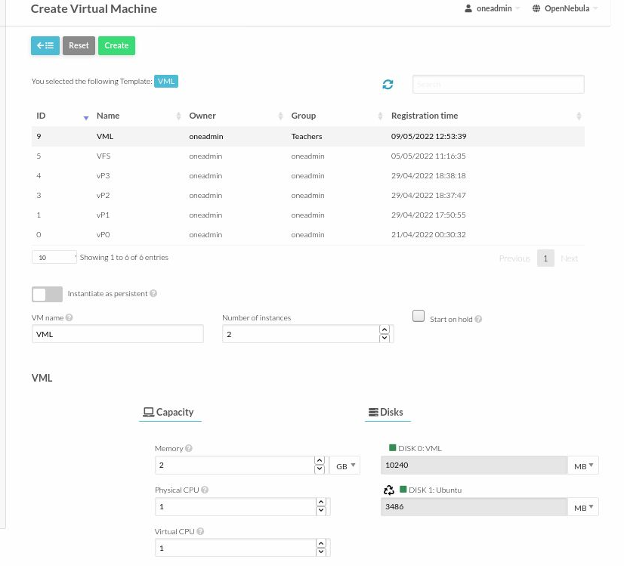

Figure 148 - Creating VML

Based off the VML template, I then checked over the settings, adding Teachers group to the virtual machine and created it.

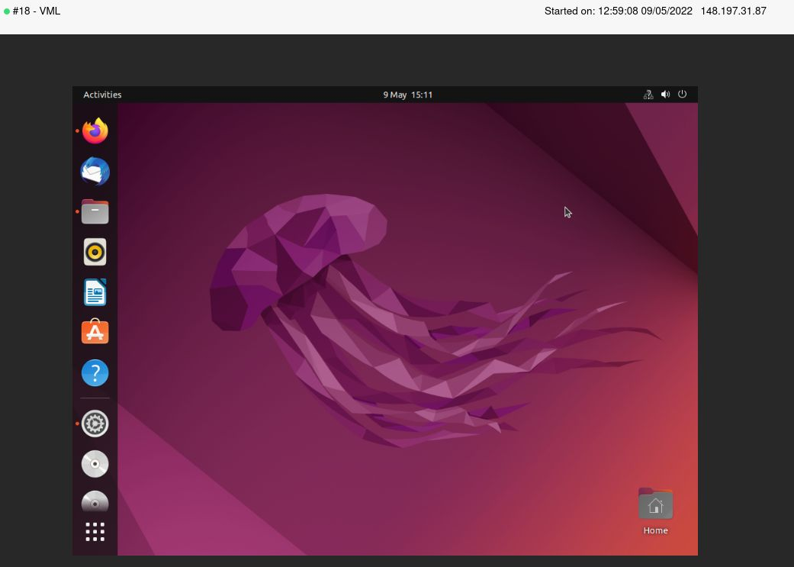

Figure 149 - Functional Ubuntu VM

Following installation, I then had a functional Ubuntu virtual machine for the Lecturers.

### Creating Student Virtual Machines

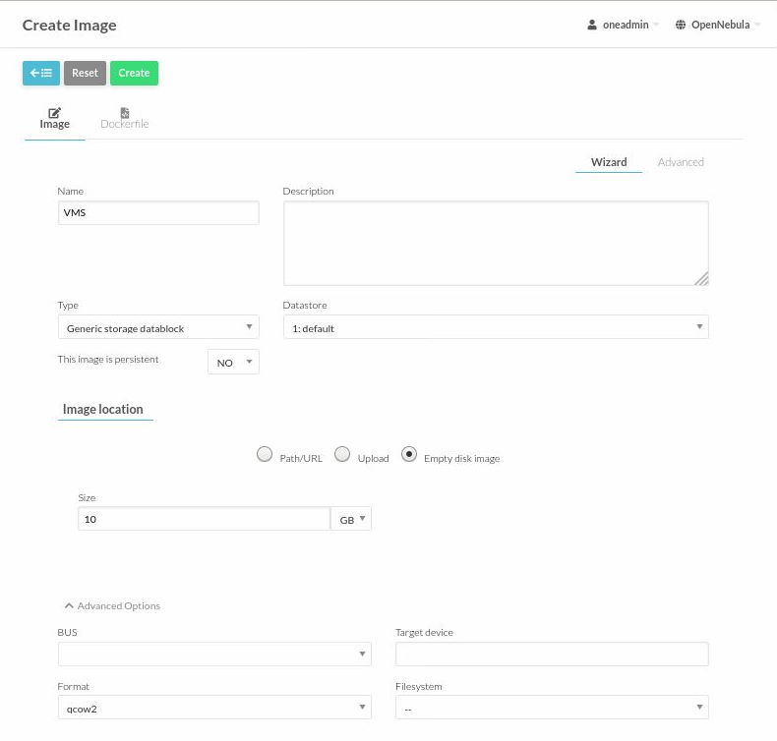

Figure 150 - Creating Student Storage

As multiple students will be using this at the same time mostly make use of the cloud storage I chose non-persistent storage and again chose the qcow2 format.

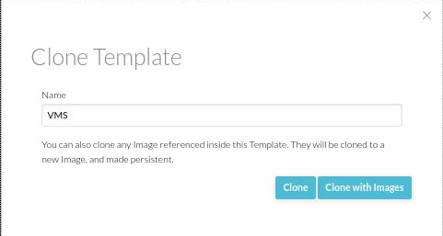

Figure 151 - Cloning net32

I then cloned the net32 template and renamed this to VMS. I will have to change the storage and the ownership, as I did with the teachers template.

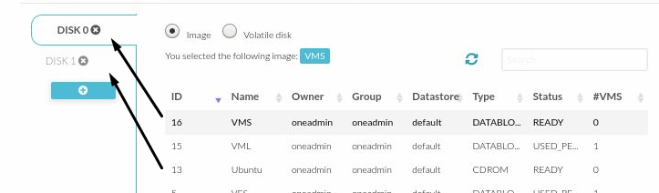

Figure 152 - Altering storage

I changed DISK 0 to utilise the new VMS image and DISK 1 to use the Ubuntu image.

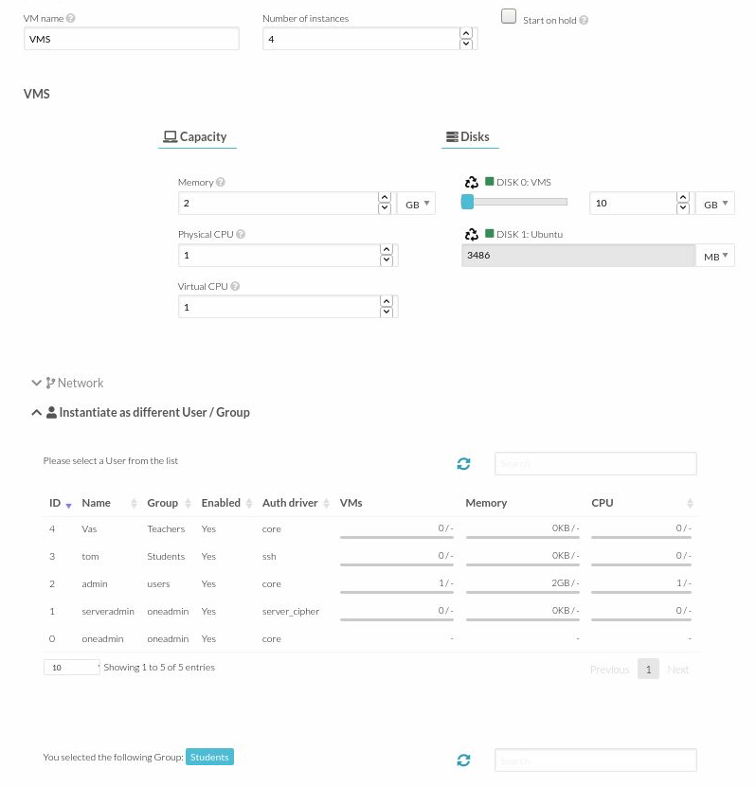

Figure 153 - Creating Students VM

When creating the VM I allocated four instances, meaning that it will create 4 copies of the same virtual machine, incrementing the IP address each time. I also allocated the VM to the students usergroup.

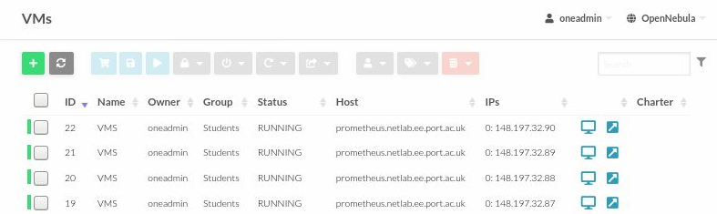

Figure 154 - Multiple instances running

After creating the virtual machines, the four student machines can be seen running in the VM menu within Open Nebula.

Following installation, I then had a functional Ubuntu virtual machine for the Lecturers.

# Conclusion

The overall setup of Open Nebula went smoothly, with the setup of both nebula and the sunstone web interface both installing without encountering any errors. This was also the case for extra software installed, both Open vSwitch and quagga installed and started without any errors after configuring the relevant networking files.

Moving onto sunstone, I also encountered no problems here when creating images, templates, virtual networks, and virtual machines. IP addresses were successfully allocated to the NFS server, and all lecturer and student clients as required and multiple instances can run.

I did encounter some networking issues when it came to connecting the virtual machines in the cloud. Prior to routing the VM’s, they naturally did not have any connection hence why quagga was implemented. After quagga was installed and configured on the host system, although routing was setup and this could be seen in the routing table, the virtual machines within the cloud were still unable to connect to the internet and testing the connection between the host and the cloud VM’s proved that the ping only worked from the host to cloud.

This connection issue only occurred after changing back to the NAT network on the host machine and configuring bridged adapters within this NAT network. When building the first bridged machine within the bridged host network, this machine had a working network connection. For this reason, I expect there is a problem within the VMware software (hypervisor used) which causes an error when a user tries to create a bridged network within a NAT network. This is shown by the lack of connection after routing the cloud virtual machines and inability to connect NFS, VML or VMS clients to the internet or nfs share.